|  |
| --- |
| **Instructor :** Ms. Le Mong Thuy  **Class :** T1.2109.E0  **Group :** 2  **Group members :**   * La Bao Minh **|**  ID-Student1333969 * Pham Nguyen Thanh Long **|** ID-Student1336989 * Do Minh Phuong Duy **|** ID-Student1285599   **Duration :** 22th November 2021 – 22th December 2021 |



*Music World*

Music World

**T1.2109.E0 – group 2**

# **ACKNOWLEGMENT**

On behalf of all the members of group 2, I would like to thank you all for the hard works, supports to make this eProject complete successfully. Especially, Ms. Le Mong Thuy, our teacher, she helped us a lot from the day that we started to study at FPT Aptech. With this eProject, she has guided us with her enthusiasm and rigorous, because of her guiding, we would be able to finish this project. Besides, I want to thank all the team member of group 3, each of the team member has been working continuously in 4 weeks in order to complete this project. The last but not least, we would like to say thank you to our family for always supporting us, creating the best conditions for us to focus on the project, and putting faith in the dreams we pursue

# **SYNOSIS**

We need to create a website that meet all the requirement of our customer, Music World. Music World is a music store that not only provide music but also contest and live music. They have a big collection about books and magazines as well. The main purpose of this website is to reach to the customer, who have interest in music and looking for a place that they can live with their passion. Come to Music World, customer can also be a member that has a lot of discount and special offer.

# 

# **PROBLEM DEFINITION**

Music has the power to cause emotions to well up within us. These feelings are gripping - often irresistible - and seem to emerge from nowhere. These feelings colour our moods, affect our perceptions and generate a behavioral pattern. The indisputable fact about music is its power to evoke emotions. Is there anyone, for whom, music is completely emotional - neutral? Music has the ability to inevitably tap the still, mysterious deep well of our emotions. However, music can produce various emotional responses in different individuals and even different responses in the same person at different times. Music may produce expressions of various emotions - peaceful, relaxing, exciting, festive, boring, unsettling, unstimulating, invigorating ... and so on.

Music is an extremely versatile medium of communication. It is capable of exploring all the features that are used in verbal communication. Moreover, it does so in an explicit and structured way, which makes it an interesting and useful window into human communication, in general. Because of this there are many music stores across the city. And the competition for providing best of the music is growing very fast.

Hence it was felt that it will be good if there is one source where one can get all the related information. In today s world internet is the best source for information sharing so a group of people took initiative in this and reached to a conclusion that a website is the best solution. You are expected to develop the site musicworld.com which will give in and out information about music.

The website is to be developed for the Windows Platform using HTML5, JavaScript and Geolocation. The site should work well in all leading browsers including Chrome, IE, Firefox etc..

# **CUSTOMER'S REQUIREMENTS SPECIFICATIONS (CRS)**

**Client: Music World**

### Project Objective:

Music World is a website that allows users to listen to online music including many genres of music and download. The website is to be developed for the Windows Platform using HTML5, JavaScript, Bootstrap, jQuery and Geolocation. The site should work well in all leading browsers including Chrome, IE, Firefox etc.

**Input to the system:**

* + - * Searching products based on album, music.
      * Register and login on website.

**Output from the system:**

* + - * A Menu should be created which would categorize all the information about the features provided in the Site For e.g. a Menu for Various categories of music, a Menu for releases in the current year etc etc.
      * The categories of music can be
* Rock
* Jazz
* Pop
* Rap
* Classical
  + - * These categories can be further divided into subcategories.
      * On clicking on any of the category would be able to give all the related information as
      * Artists details
* Personal details
* Career achievements
* Collection
  + - * Various albums in the respective category.
* Album release details
* Artist
* Songs
* Instruments related to the category
* Events taking place in that category
* Site should also be displaying new releases, best of the year, collections from top composers.
* It should also display the reviews about various albums or artists under reviews section.
* User should be able to perform searches by
* Artist
* Album
* Release Date of album.
* There would be two types of users: registered and non-registered users.

**Process**:

* + - * Allows customers to join membership.
      * Validate data input from users.

**Expected delivery date: 22 DEC 2021**

**List of deliverables:**

* + - * Document Word.
      * User Guide.
      * Source code.

### **Hardware/ Software Requirements:**

* **For developer**

**Hardware**

* A minimum computer system that will help you access all the tools in the courses is a Pentium 166 or better
* 64 Megabytes of RAM or better

**Software**

* Notepad/HTML editor
* Dreamweaver
* IE 5.0/ Netscape 6.0
* **For web users**

**Hardware**

* + Intel Pentium 4 processor or higher
  + 512 Megabytes of RAM or higher

**Software**

* + Windows 10
  + Web browsers such as Chrome , Microsoft Edge

**SCOPE OF THE WORK (IN BRIEF)**

After a long and detailed discussion, our group has decided to create a website contain the following webpages:

1. **Homepage:** Display information about new song
2. **Music:** Information of The categories of music
3. **Singer:** Arist details
4. **Liveshow: Event,..**
5. **About: information of us**
6. **Login:** Allow users sign up or sign in to the website
7. **Contact:** Display the address of the company, allow customers to request any information they want to Music World.

# **Architecture and design of the system**

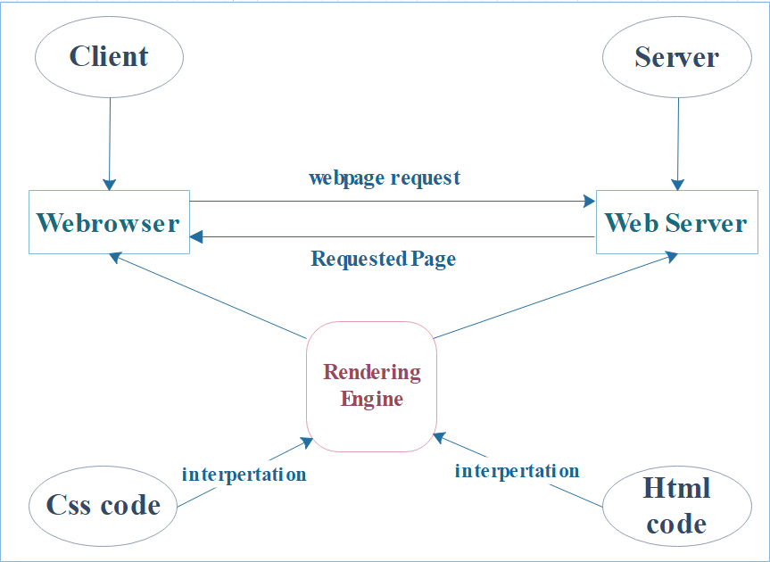

# **Diagram of the website**

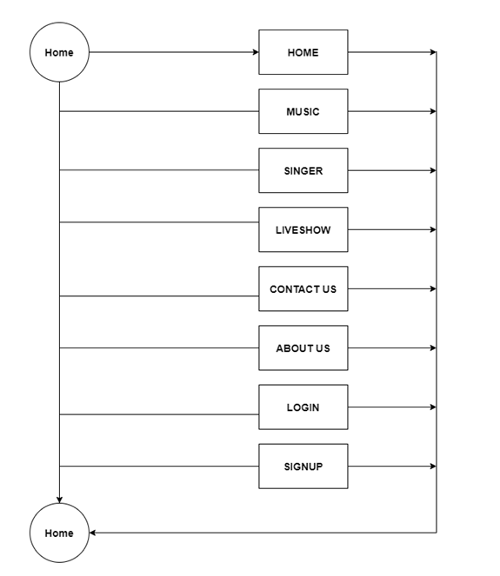

# 

# **TASK SHEET REVIEW 1**

|  |  |  |  |  |  |  |  |
| --- | --- | --- | --- | --- | --- | --- | --- |
|  | | Project Title: | Activity Plan Prepared By: | Date of Preparation of Activity Plan: | | | |
| Sr. No. | Task | Music World | Minh | Actual  Start Date | Actual Days | Team  Mate Names | Status |
| 1 | Problem Statement | 16-Nov-2021 | 1 | Long | Completed |
| 2 | Analysis of Rhythm House requirements about the website | 16-Nov-2021 | 1 | Minh | Completed |
| 3 | The scope of the work (in brief) | 16-Nov-2021 | 1 | Minh | Completed |
| 4 | Architecture and design of the system | 16-Nov-2021 | 1 | Duy | Completed |
| 5 | Diagram of the website | 16-Nov-2021 | 1 | Long | Completed |
| 6 | Task Sheet | 16-Nov-2021 | 1 | Minh | Completed |

|  |  |
| --- | --- |
| Date: | |
| **Signature of Instructor:**  **Ms. Le Mong Thuy** | **Signature of Team Leader:**  **La Bao Minh** |

# **MOCK OF THE WEBSITE**

1. **Homepage**

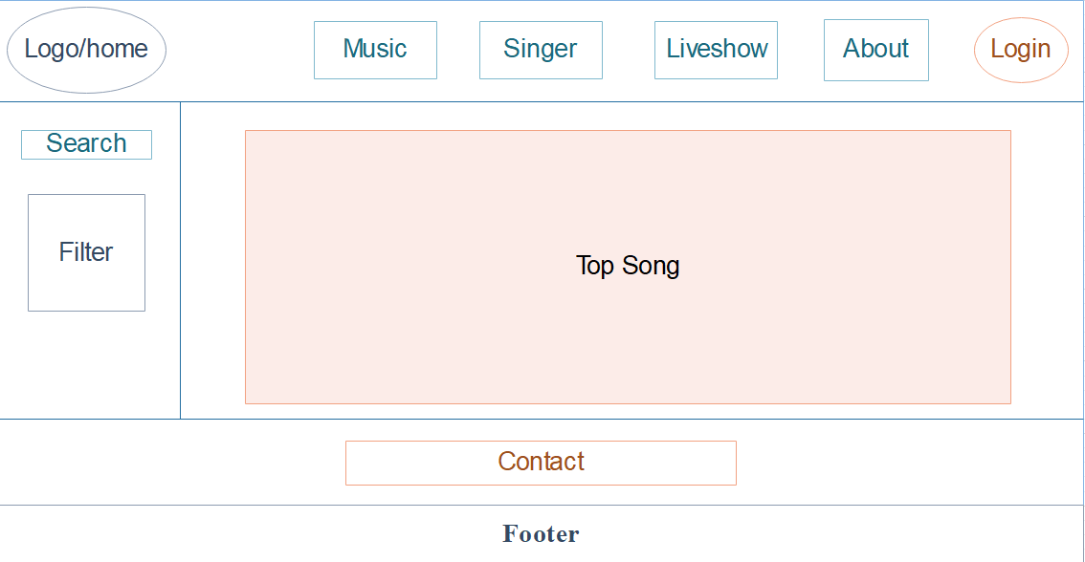

1. **Music**

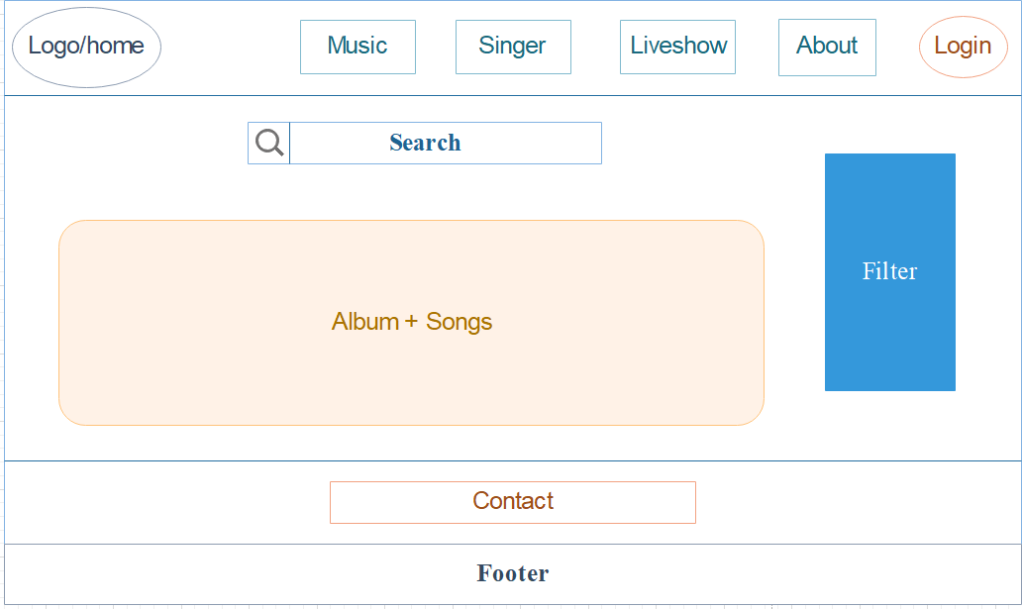

1. **Singer**

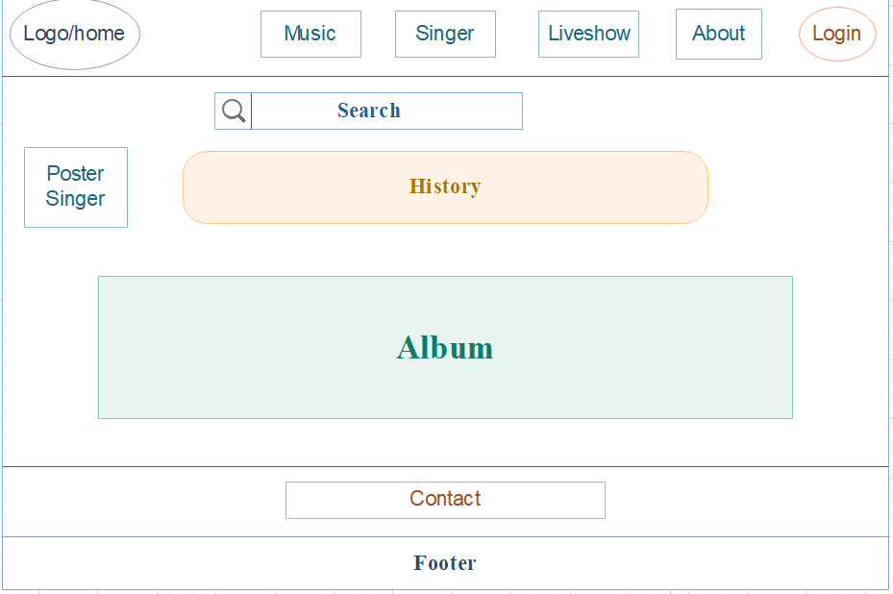

1. **Live Show**

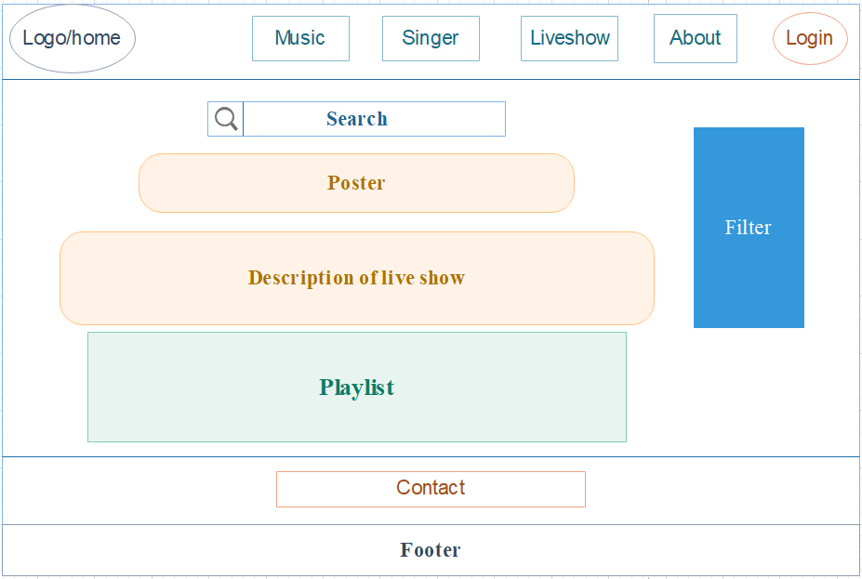

1. **About**

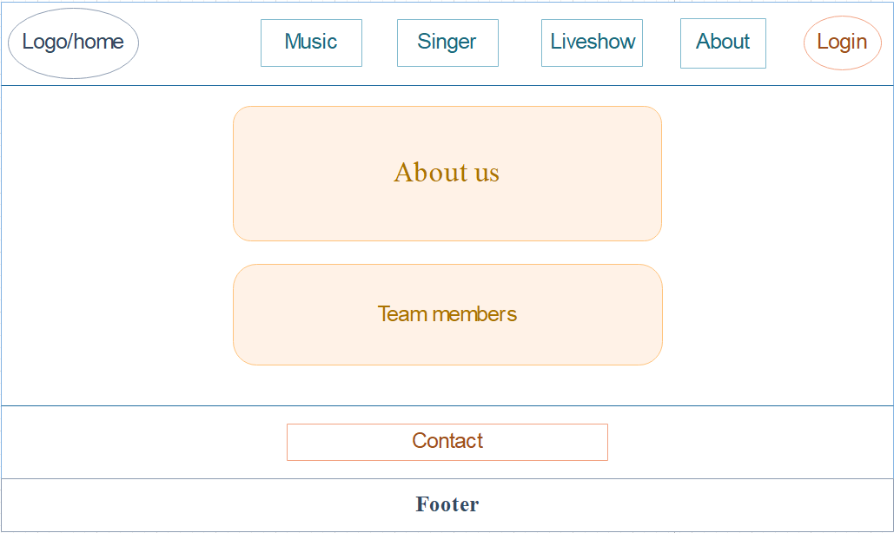

1. **Login**

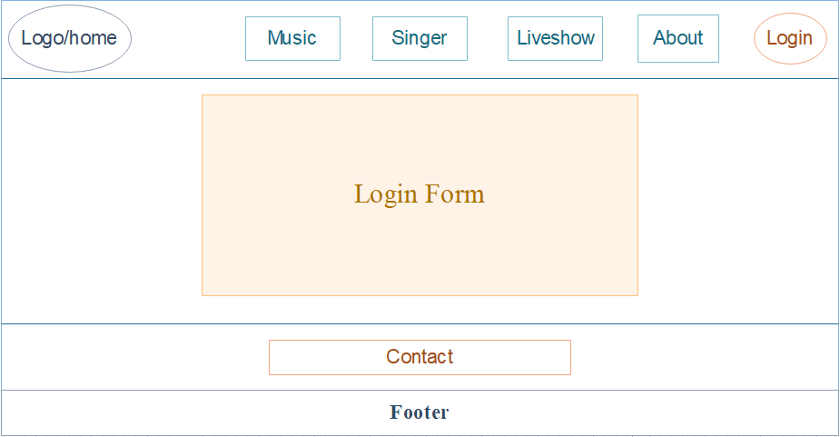

1. **Register**

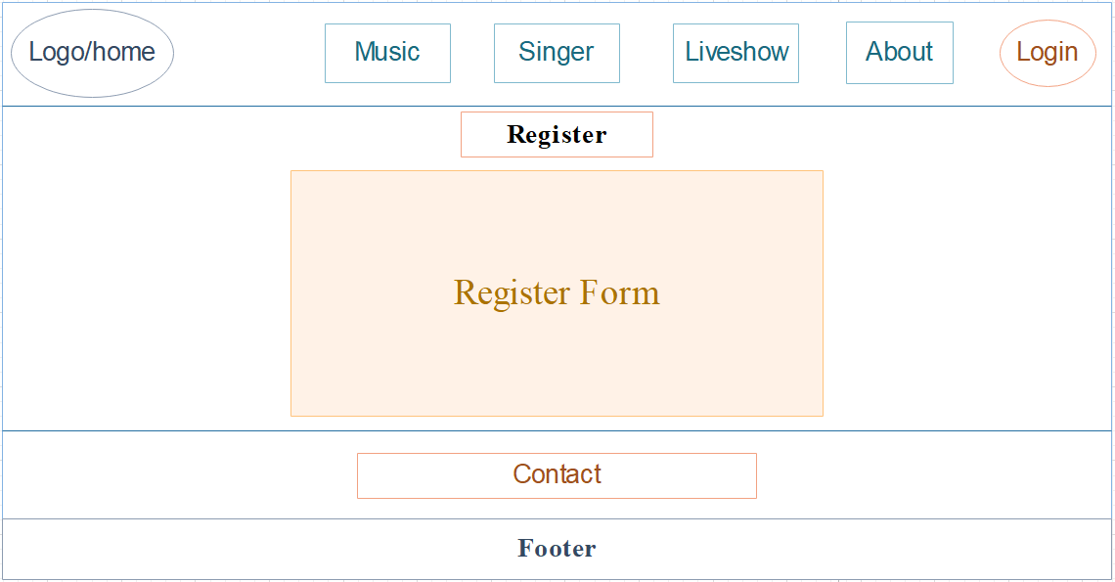

1. **Profile user**

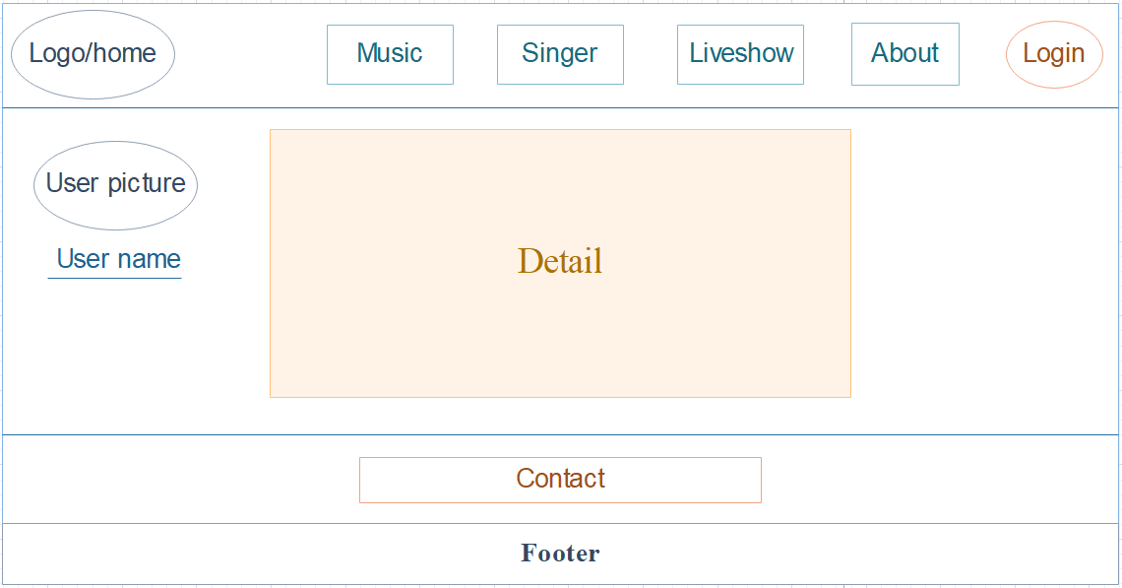

# TASK SHEET REVIEW 2

|  |  |  |  |  |  |  |  |
| --- | --- | --- | --- | --- | --- | --- | --- |
|  | | Project Title: | Activity Plan Prepared By: | Date of Preparation of Activity Plan: | | | |
| Sr. No. | Task | Music World | Minh | Actual  Start Date | Actual Days | Team  Mate Names | Status |
| 1 | Site map | 16-Nov-2021 | 1 | Duy | Completed |
| 2 | Mock of the website | 16-Nov-2021 | 1 | Minh | Completed |
| 3 | Task sheet | 16-Nov-2021 | 1 | Minh | Completed |

|  |  |
| --- | --- |
| Date: | |
| **Signature of Instructor:**  **Ms. Le Mong Thuy** | **Signature of Team Leader:**  **La Bao Minh** |

# **WEBSITE DESCRIPTION**

1. Home Page
2. Description: update music of this day and Classify it.
3. Screen shot

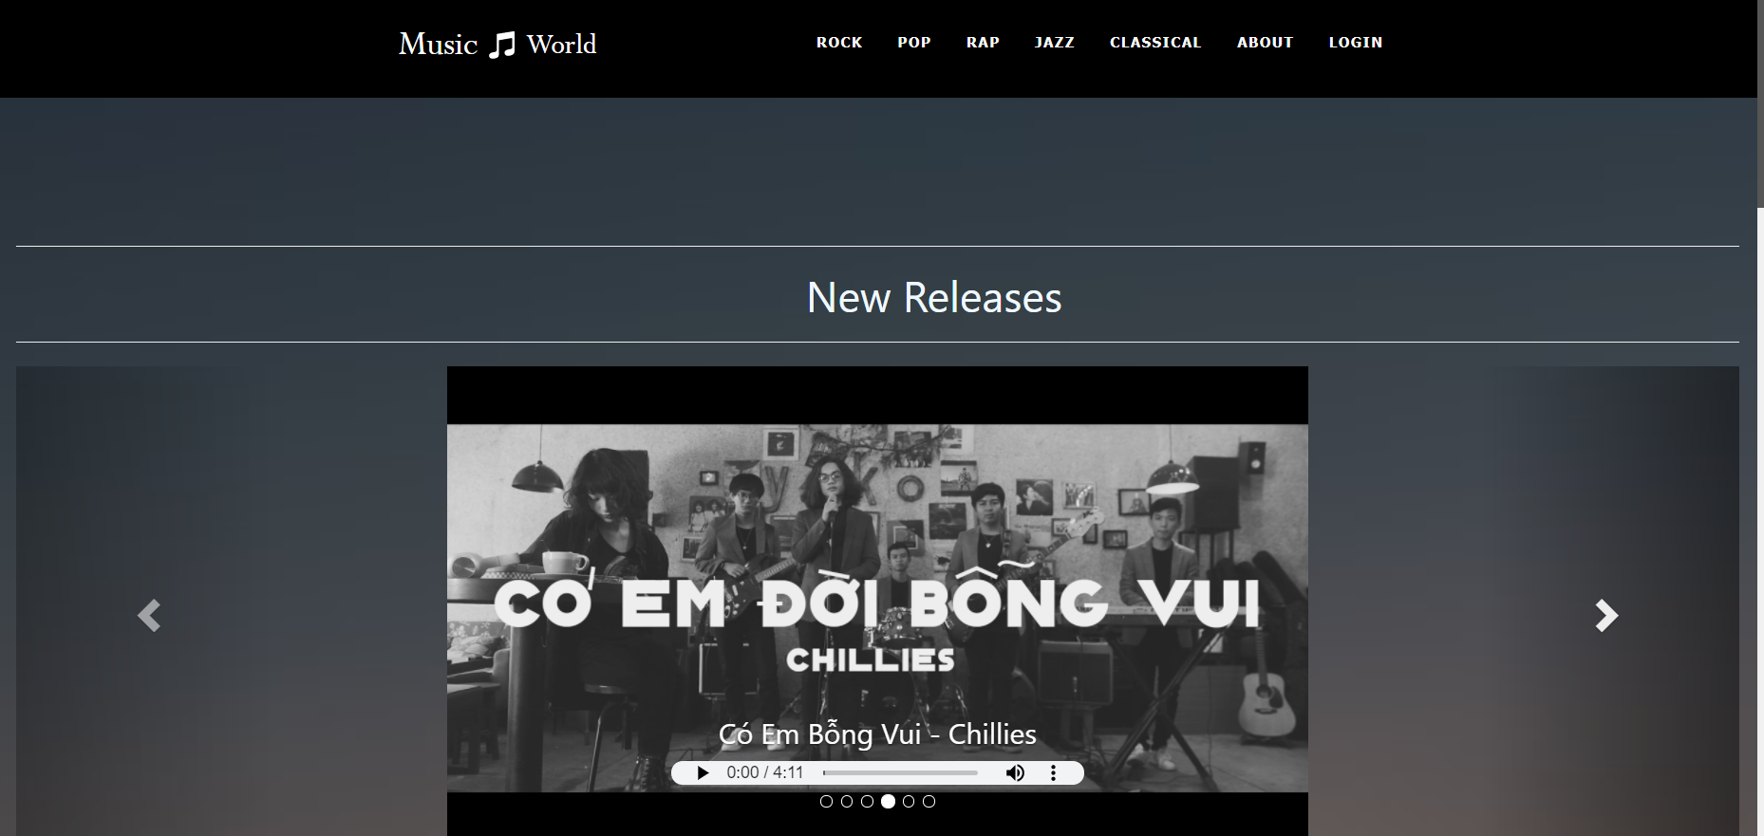

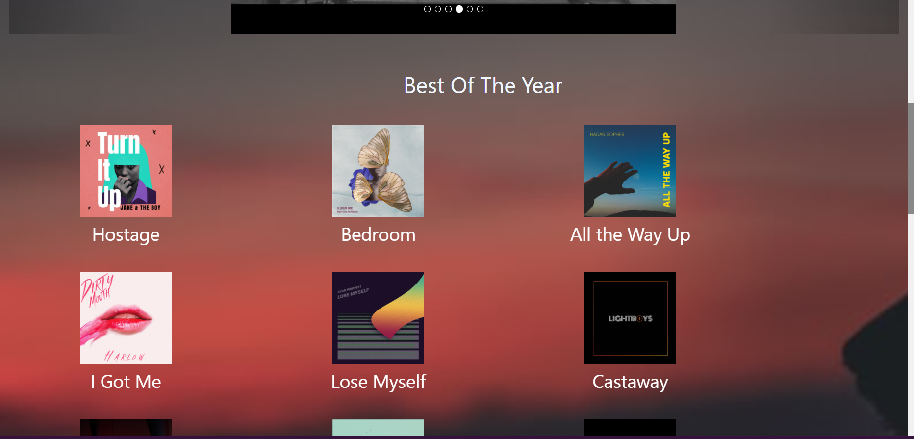

1. Pop, Jazz, Rock, Classical, Rap
2. Description: It will have song (all song of the music) , history ( including event, all information of the music, ) and artist.
3. Screen shot:
4. **ROCK**

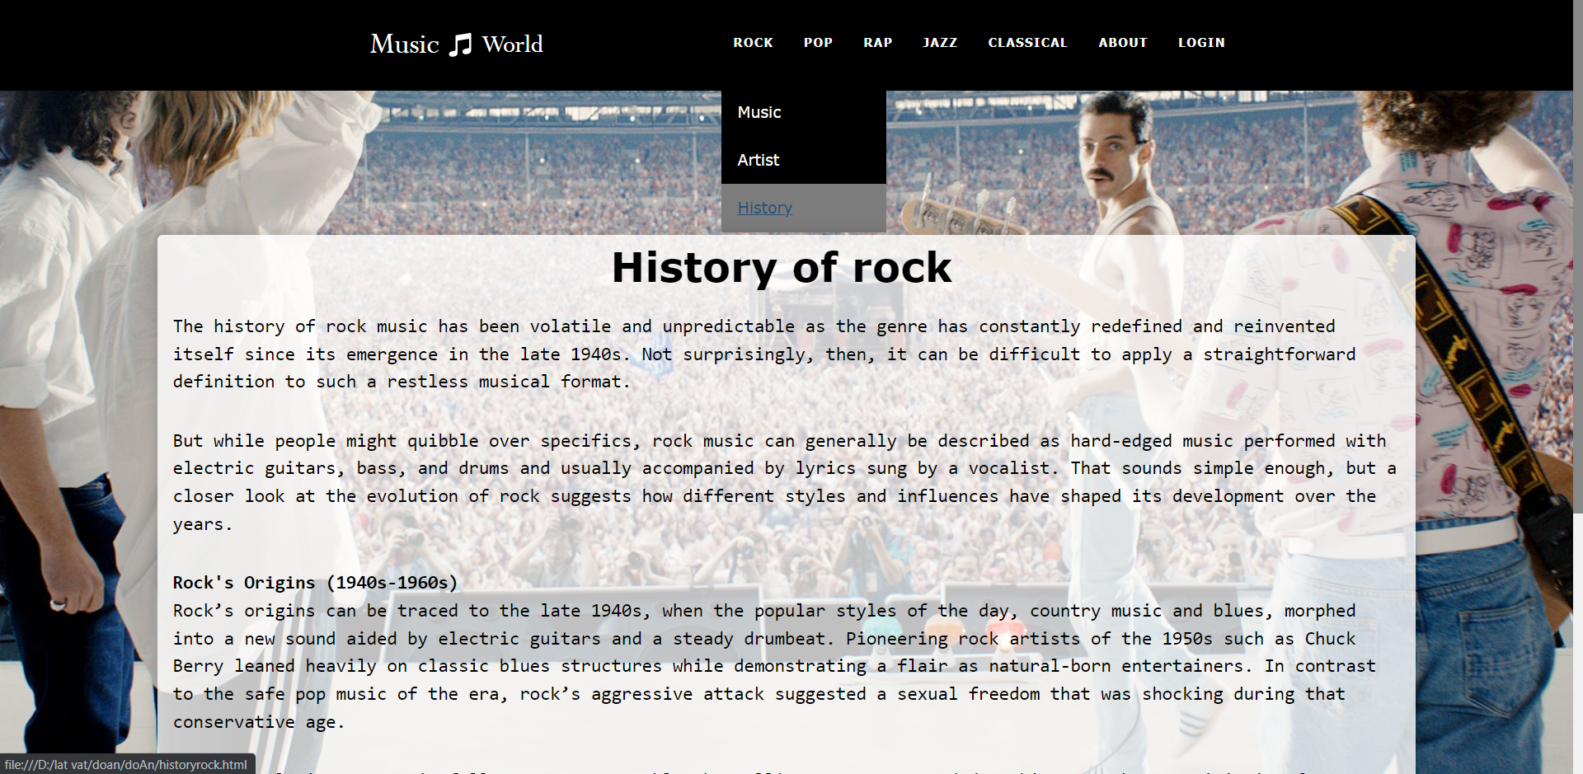

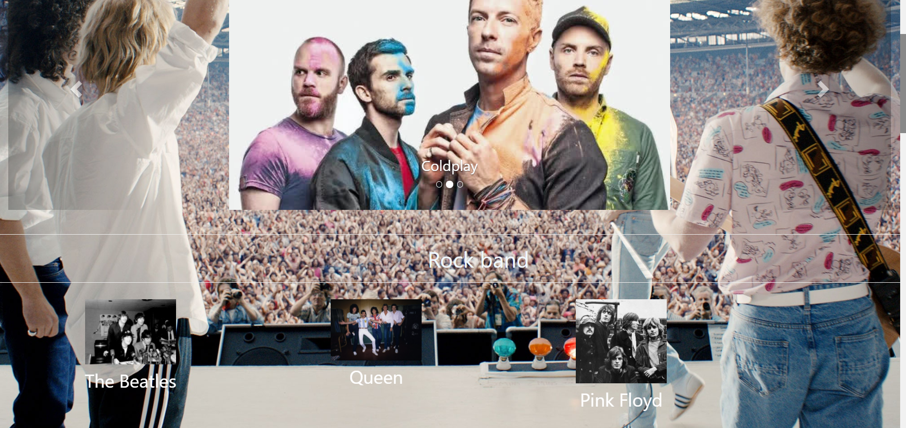

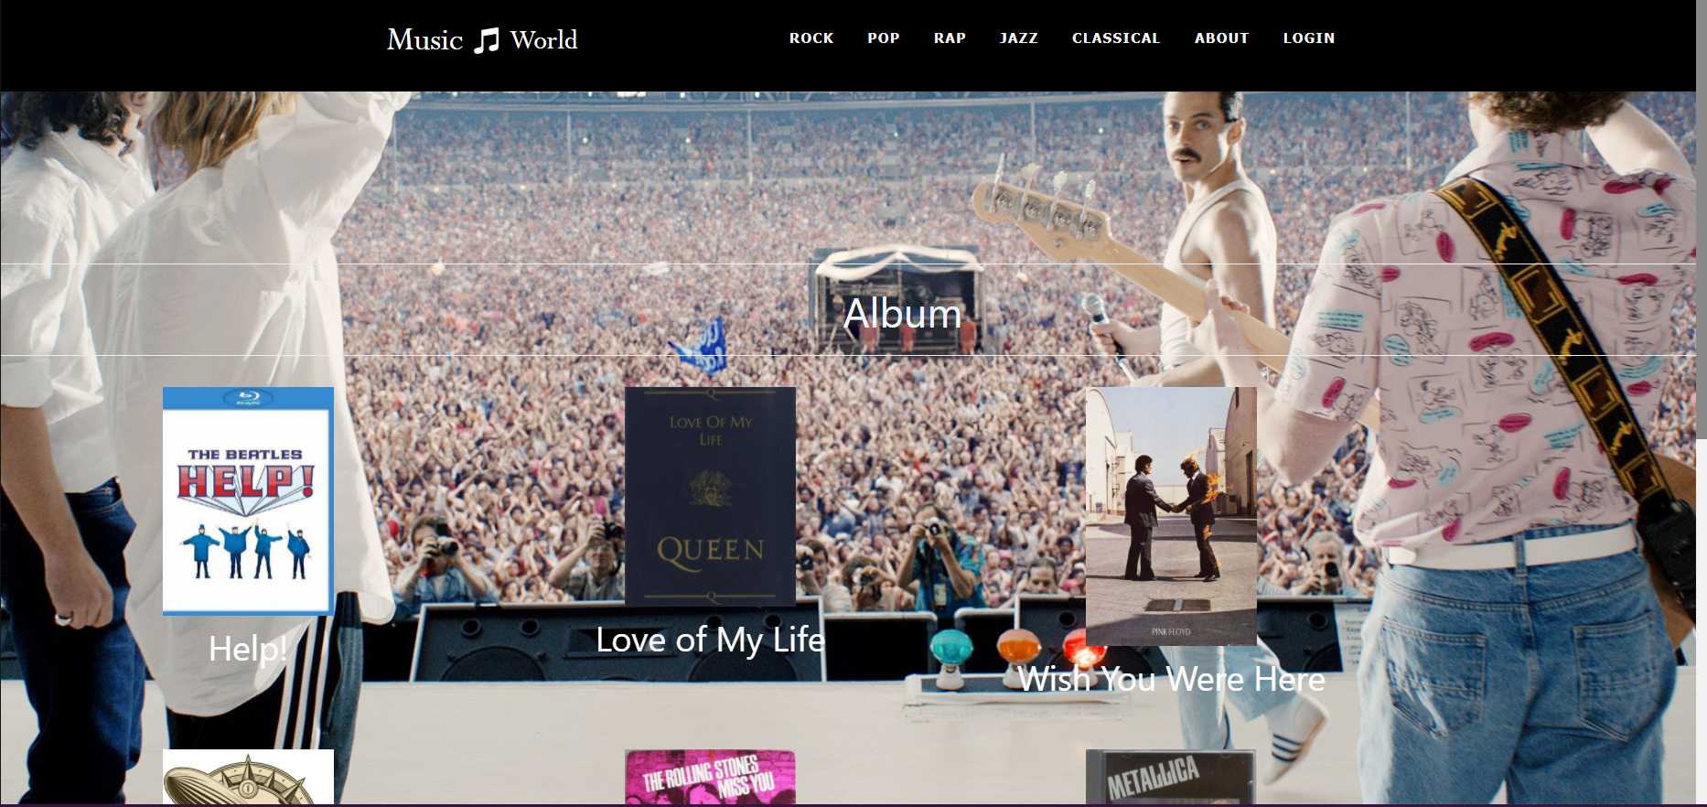

1. **POP**

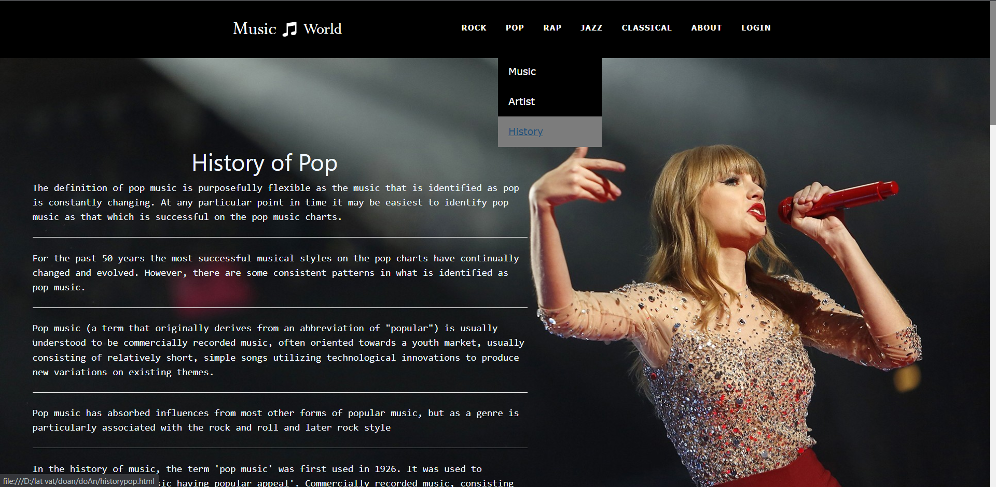

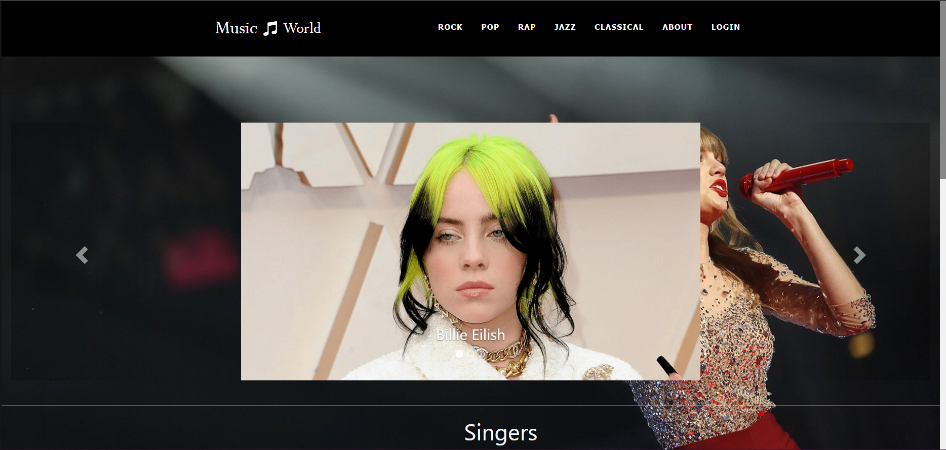

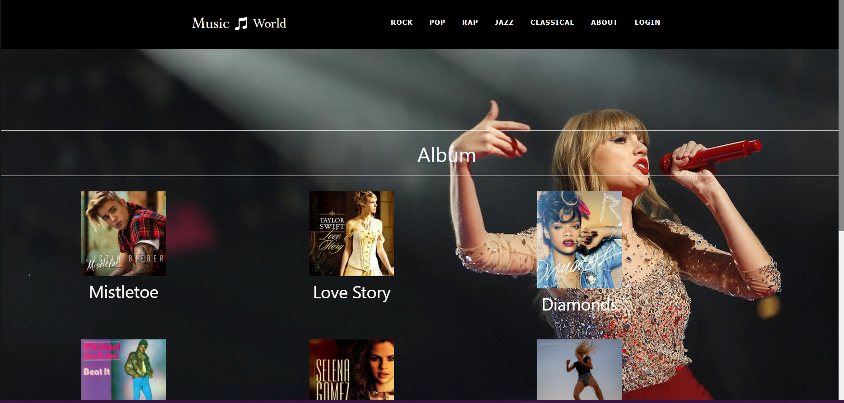

1. **RAP**

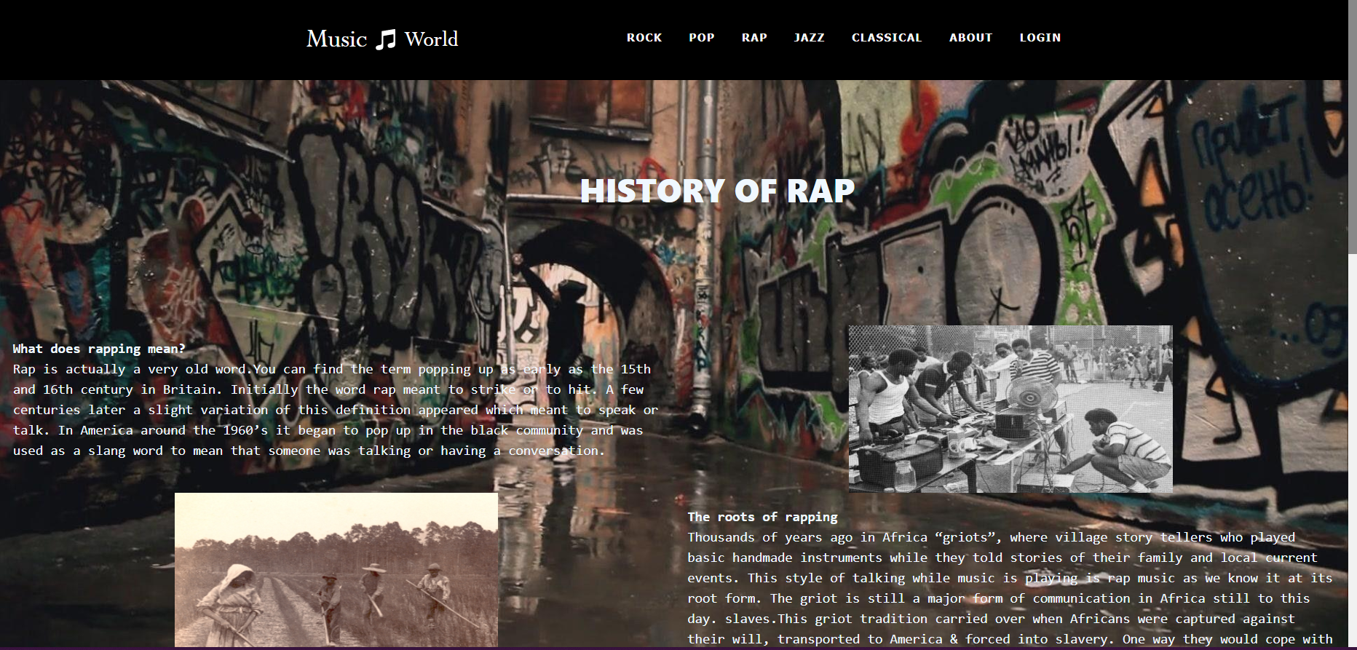

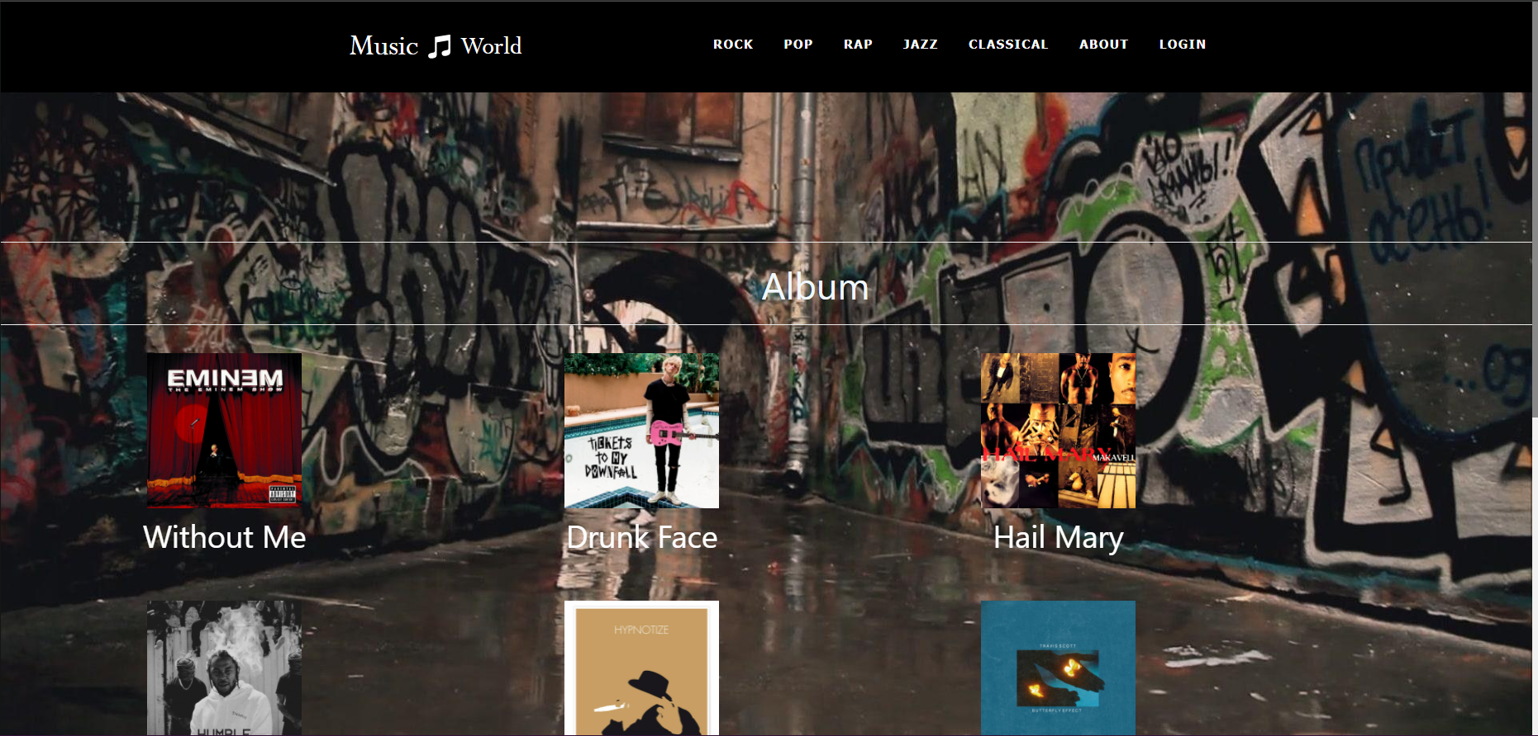

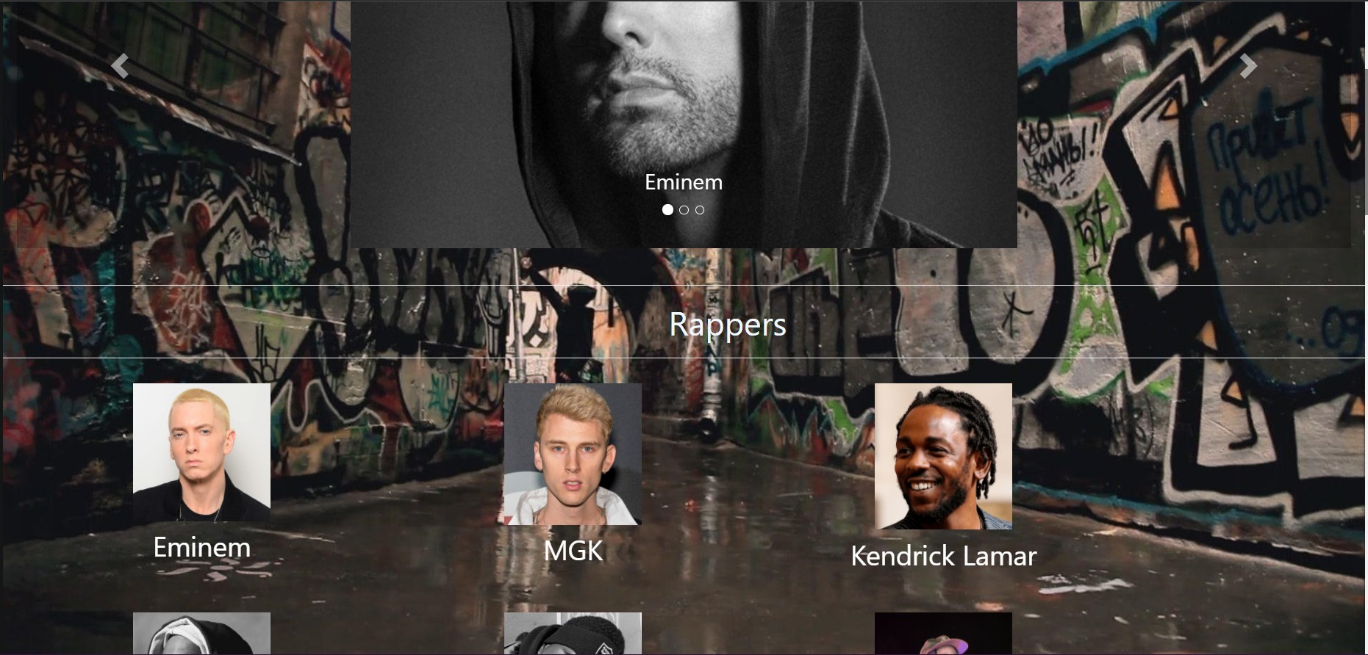

1. JAZZ

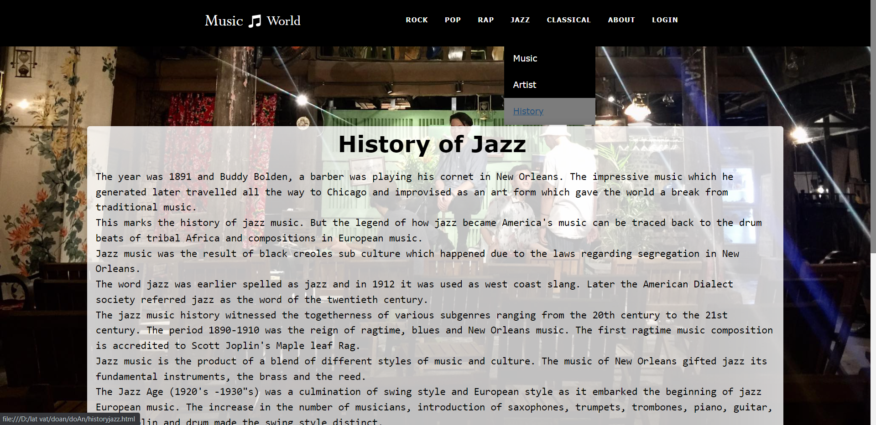

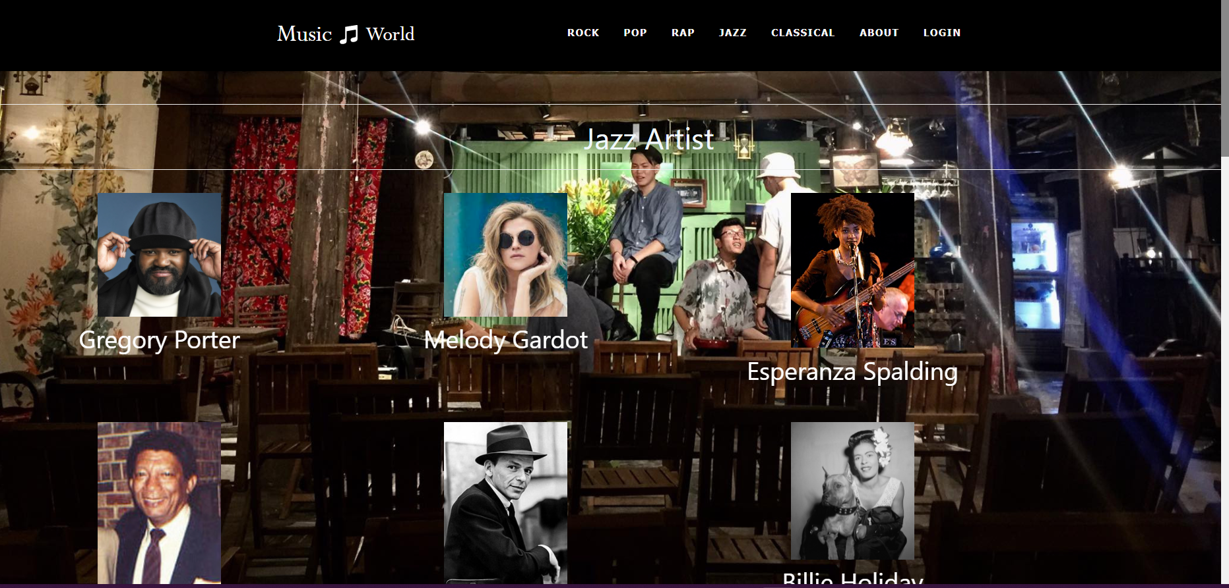

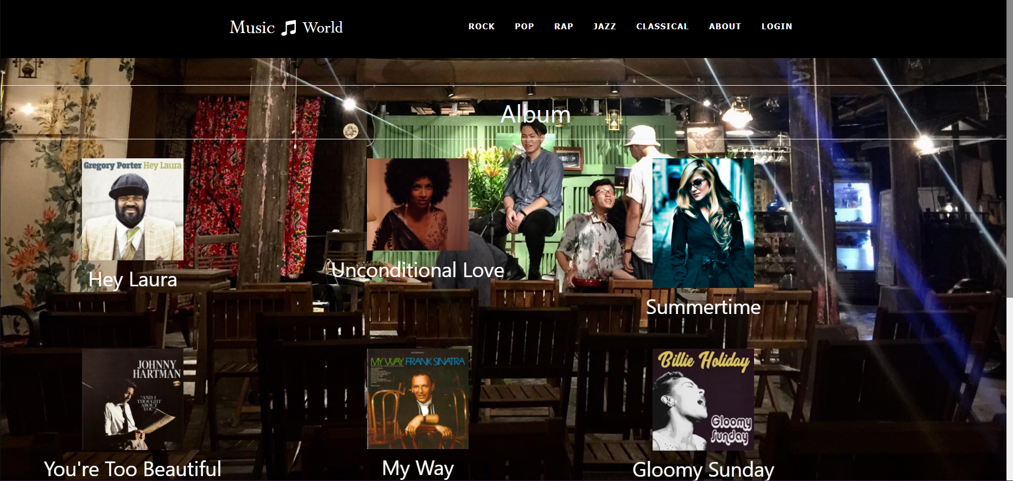

1. CLASSICAL

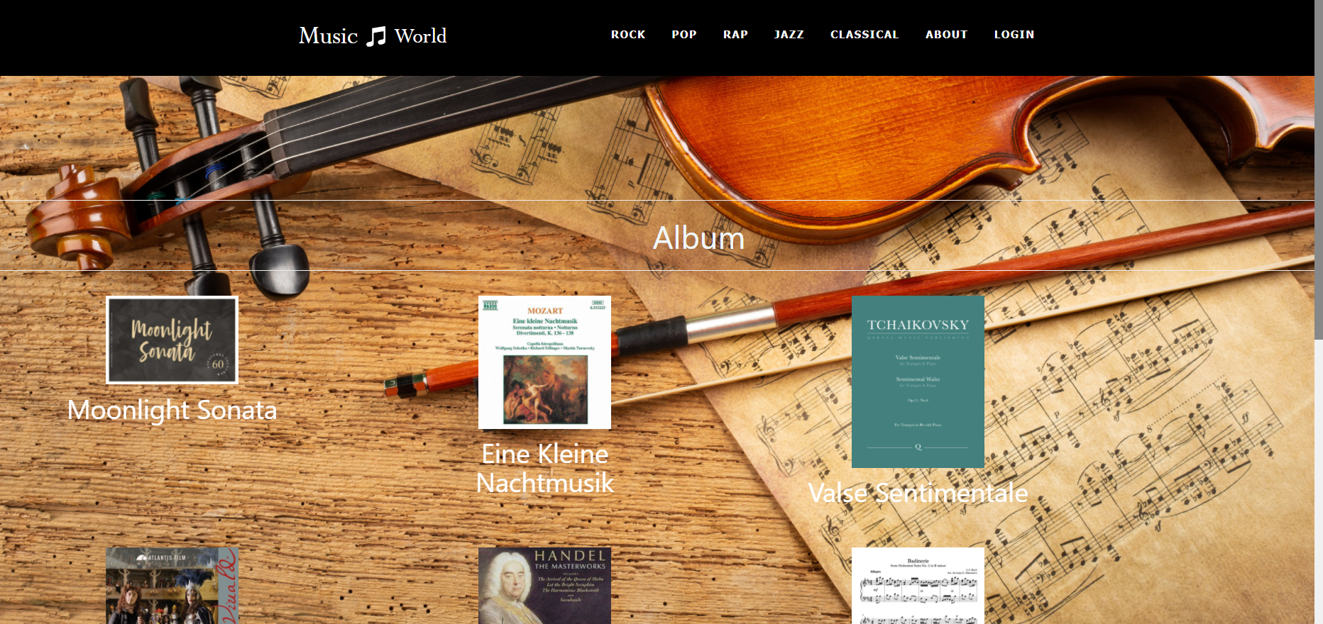

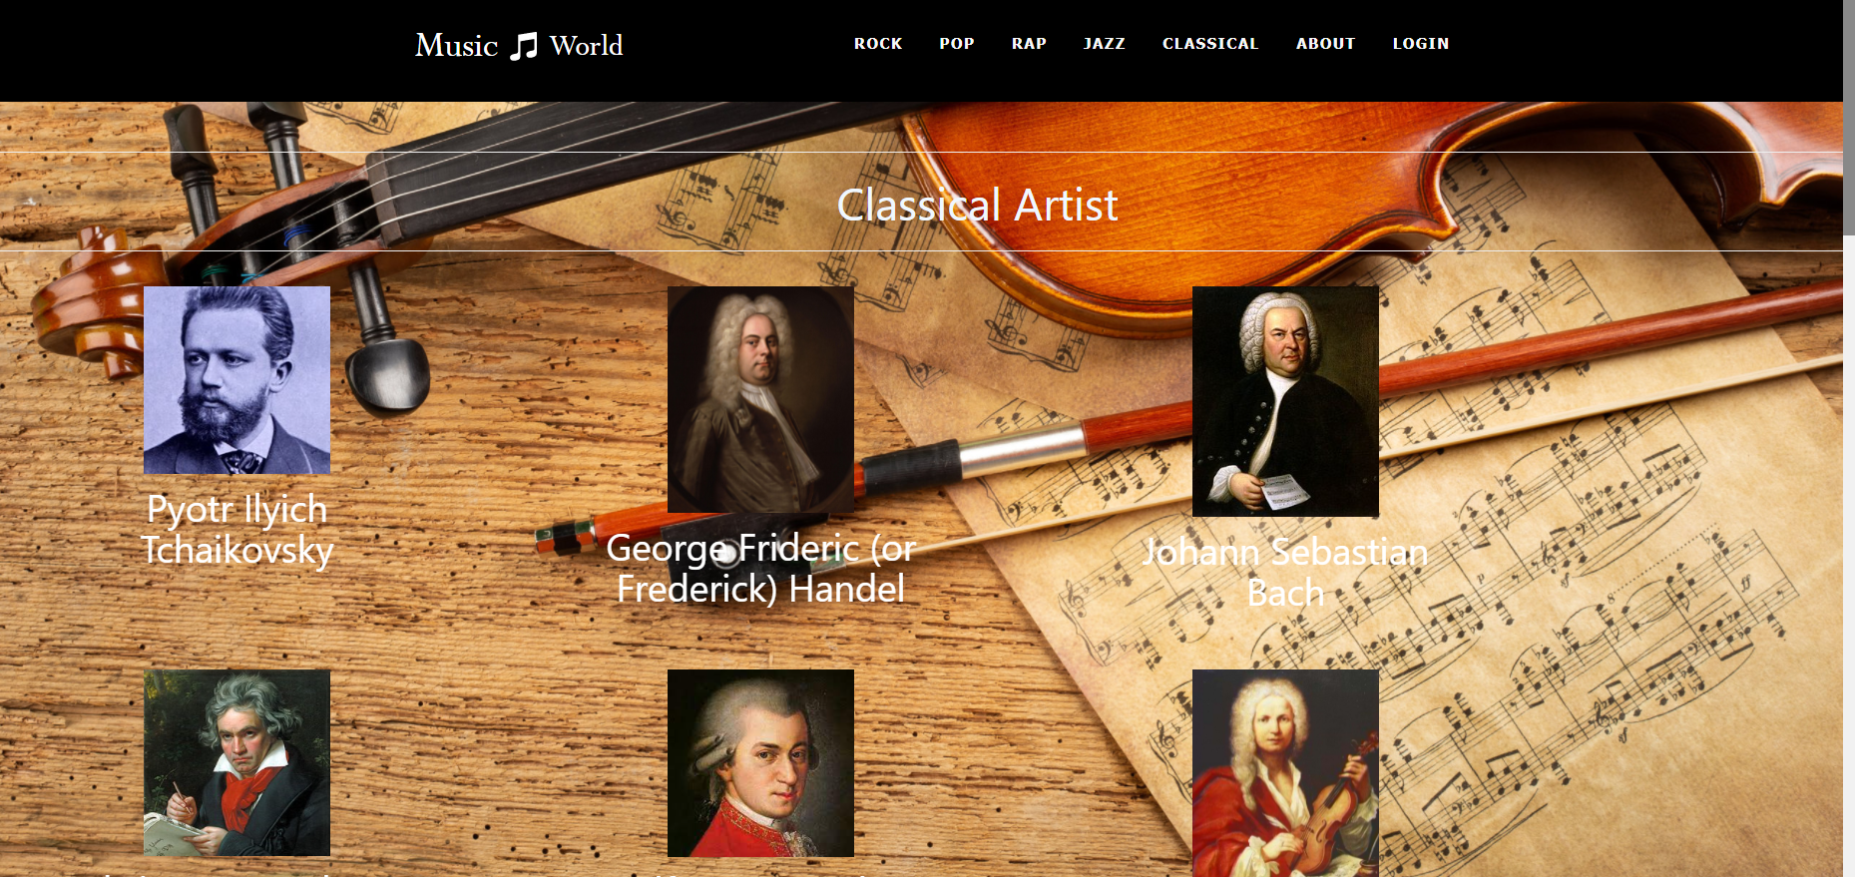

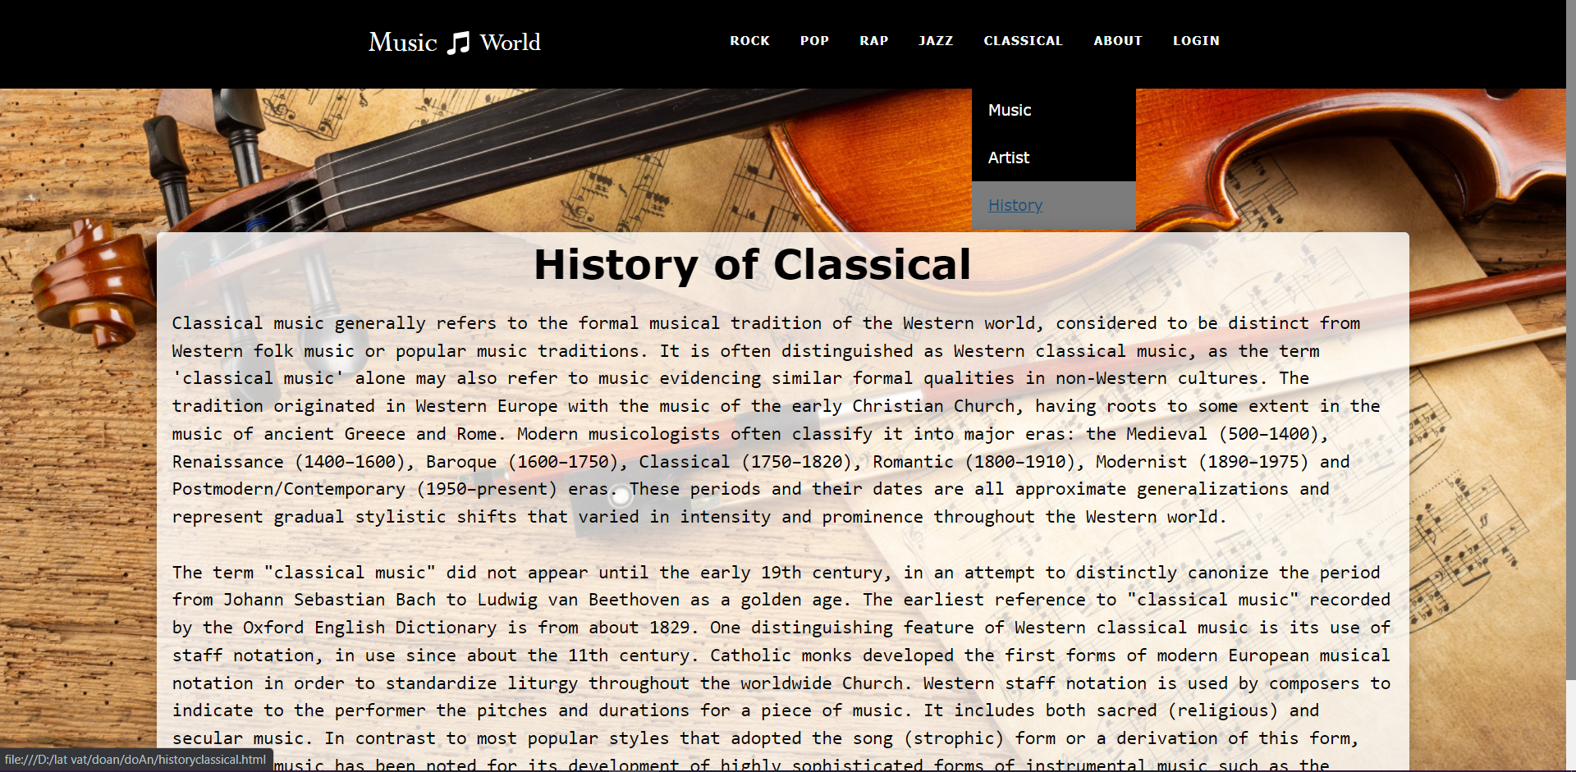

1. ABOUT US & Contact

A) information of team

B) screen shot:

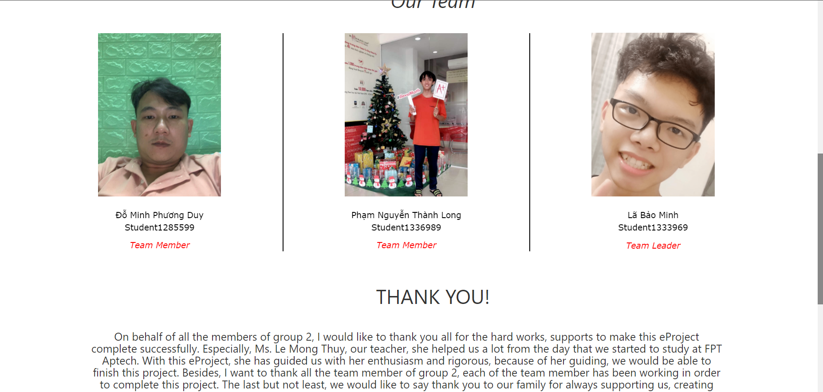

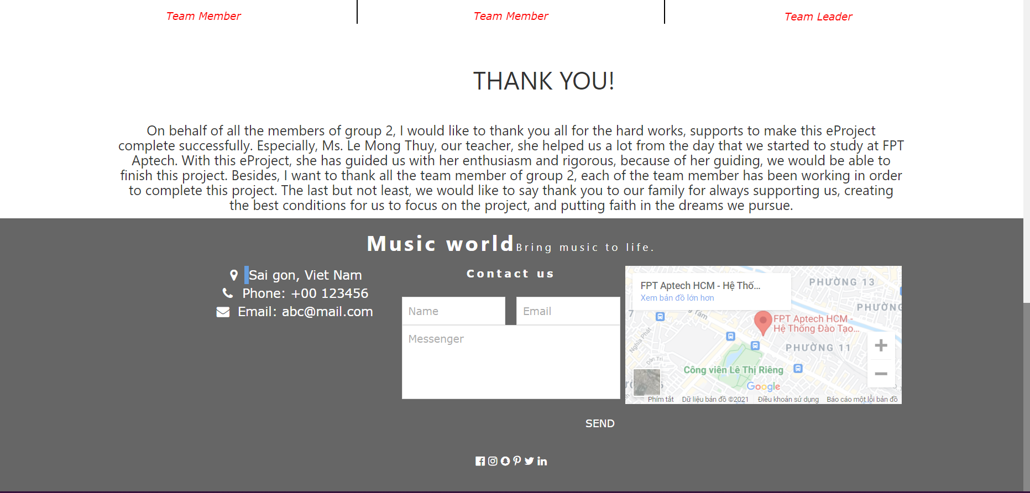

1. LOGIN

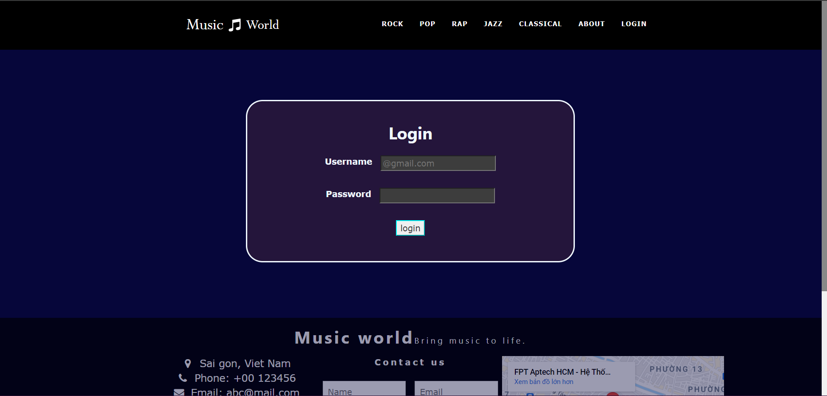

# **JAVASCRIPT DESCRIPTION**

1. **Home** 
   1. Description:

Store , play music and slide show

* 1. Screen shot:

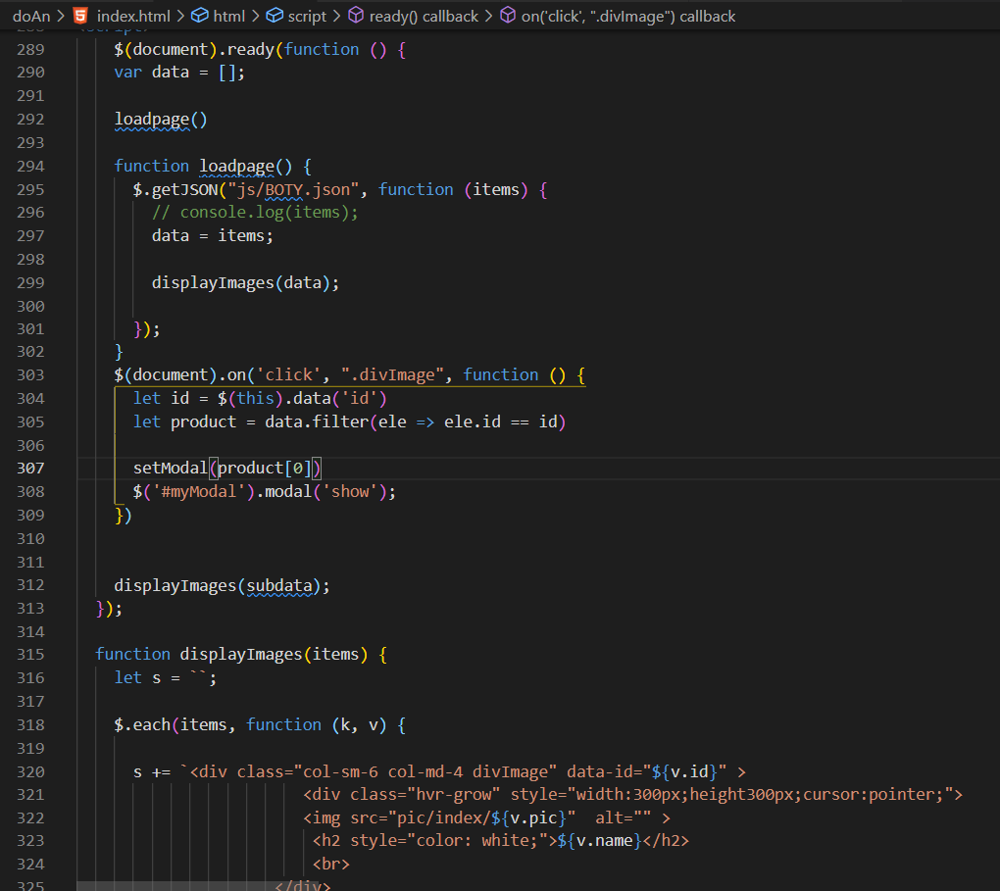

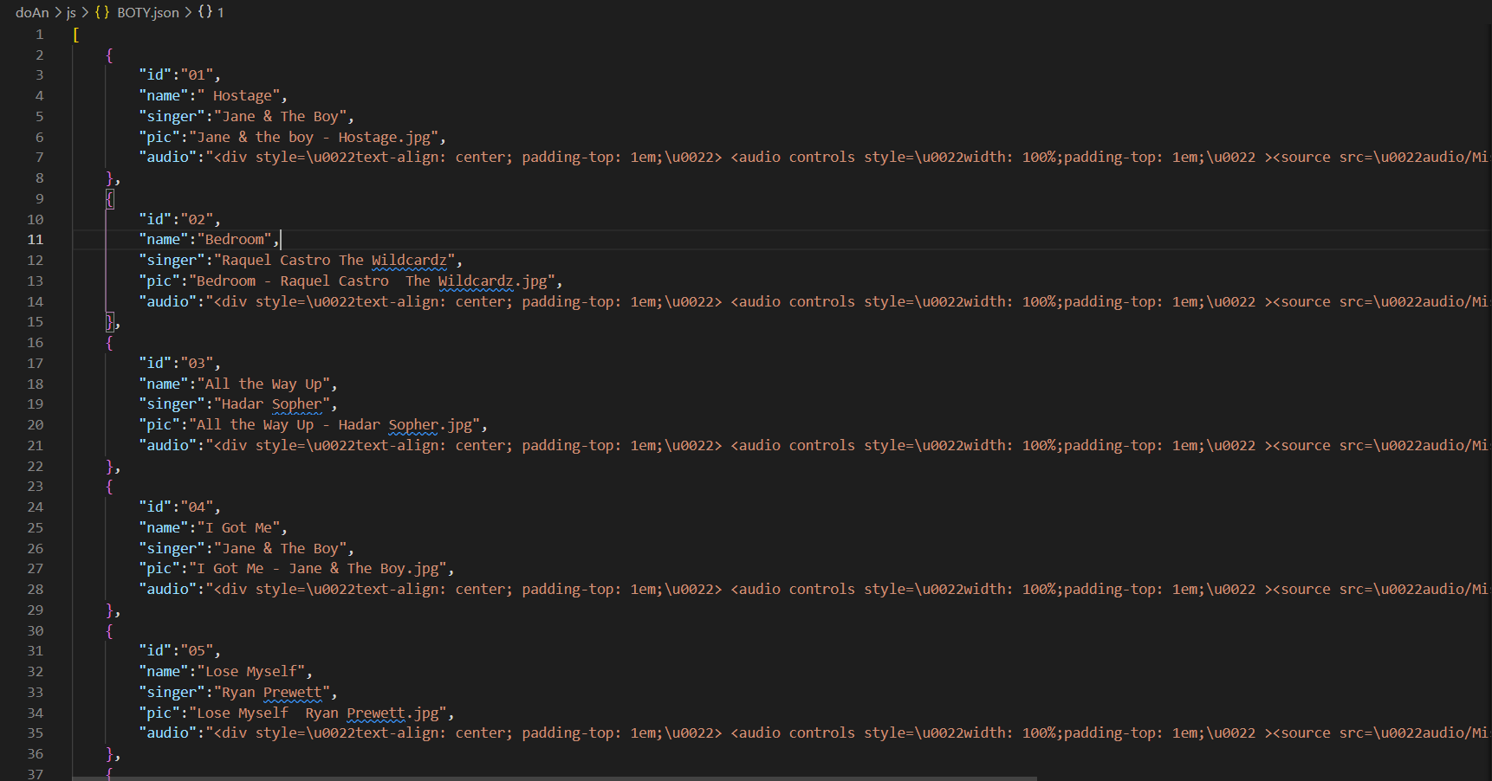

1. **ROCK/POP/RAP/JAZZ/CLASSICAL**
2. Description:

Store information of artist , history, show the infomation and play music

1. Screen shot:
2. **ROCK**

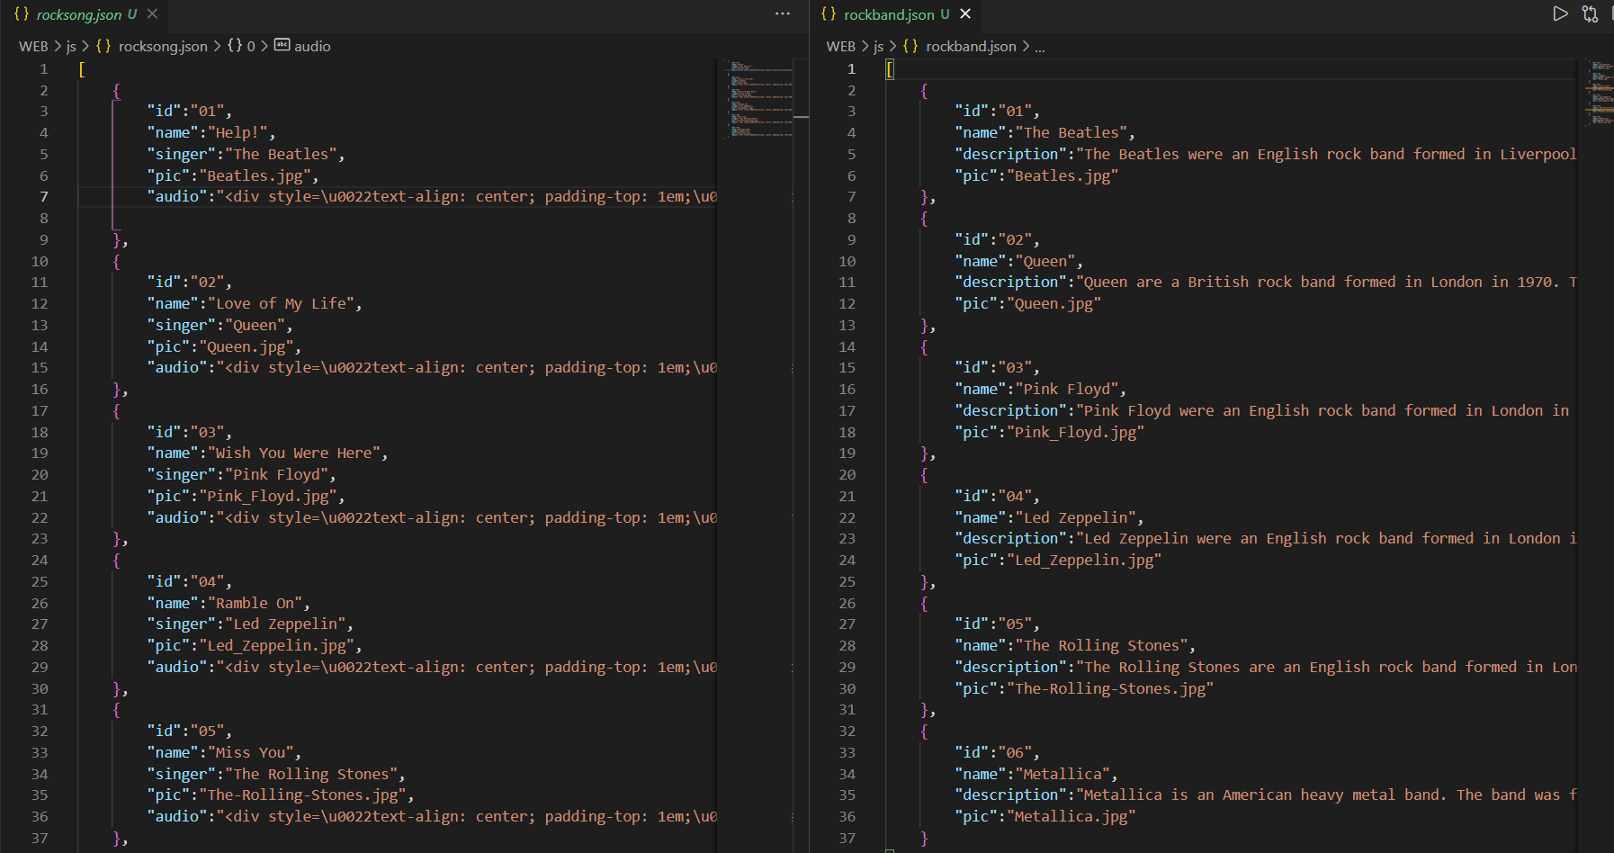

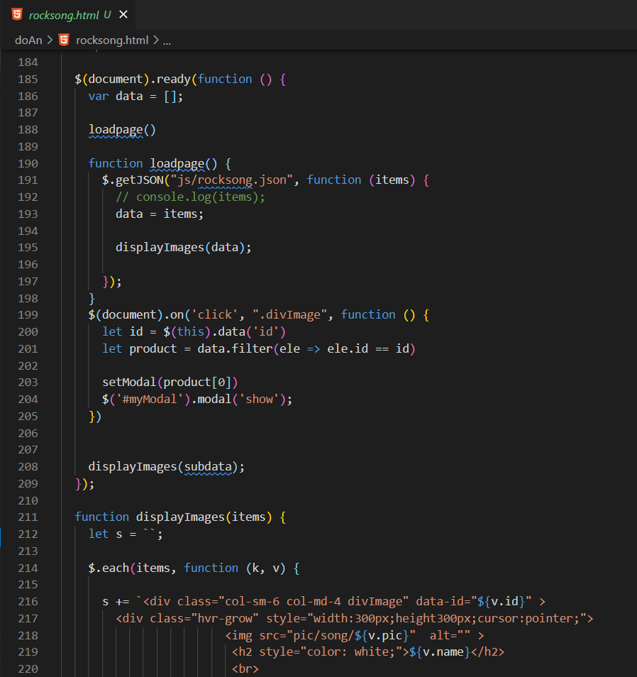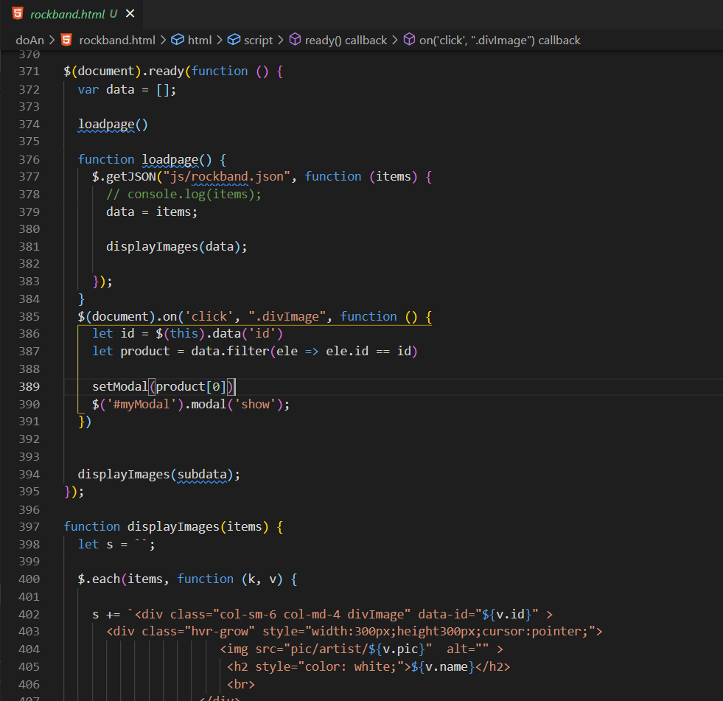

1. **POP**

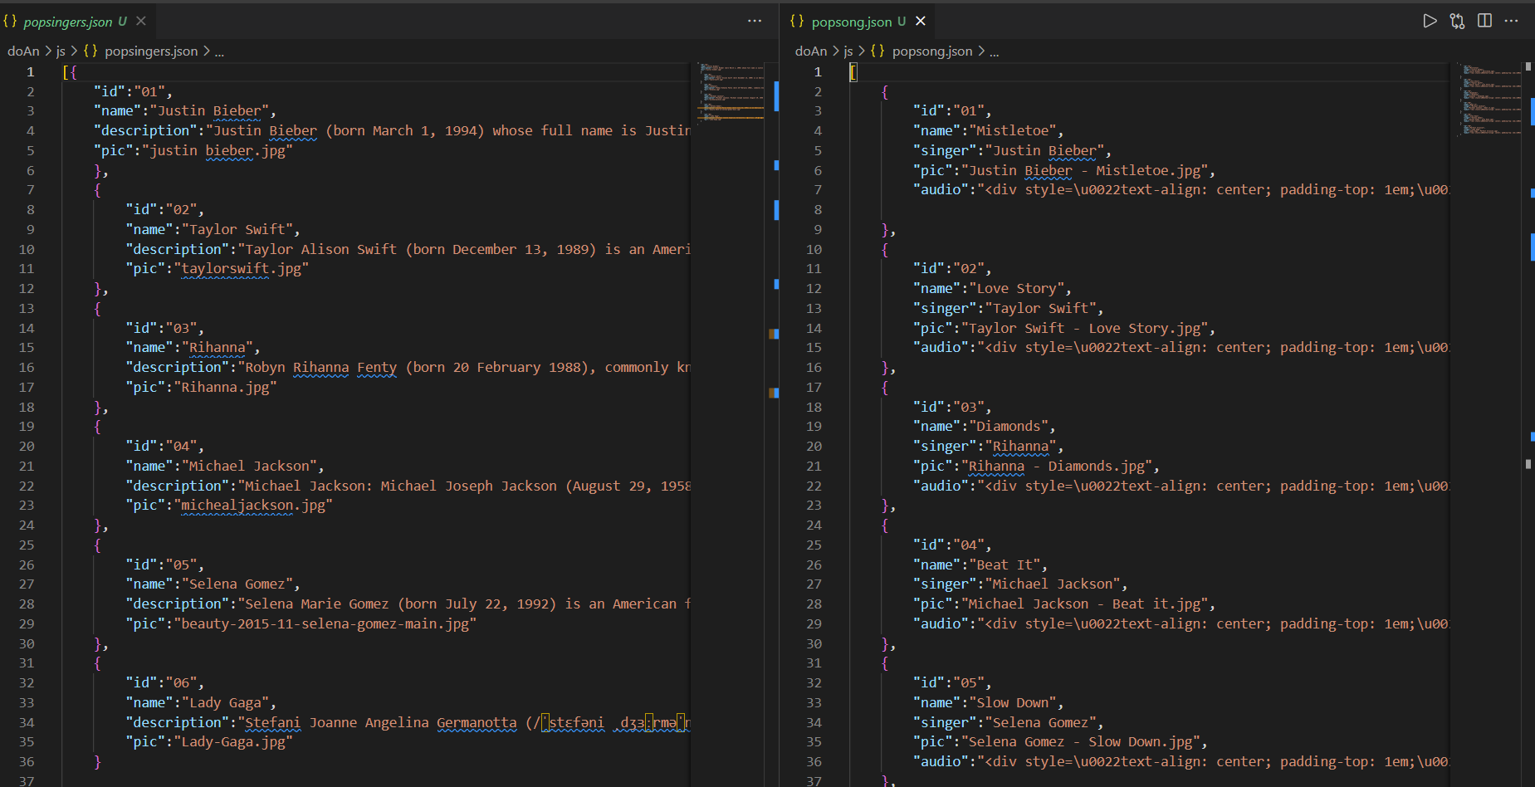

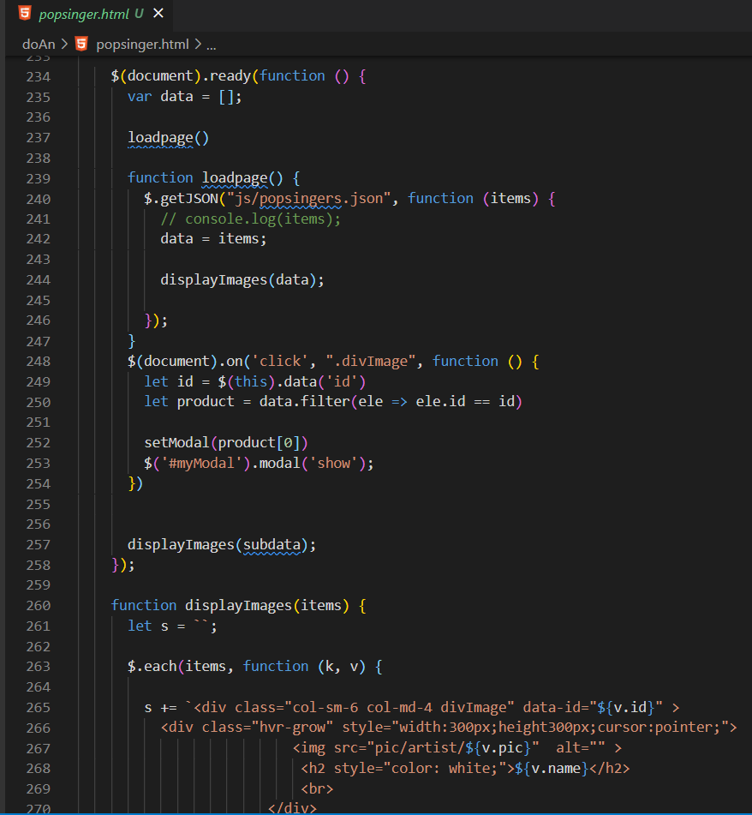

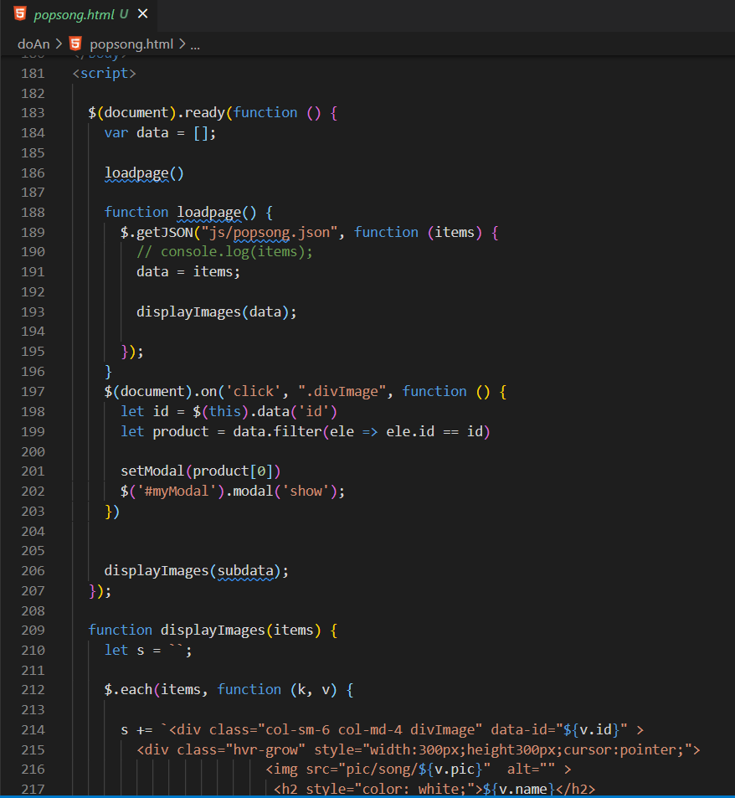

1. **RAP**

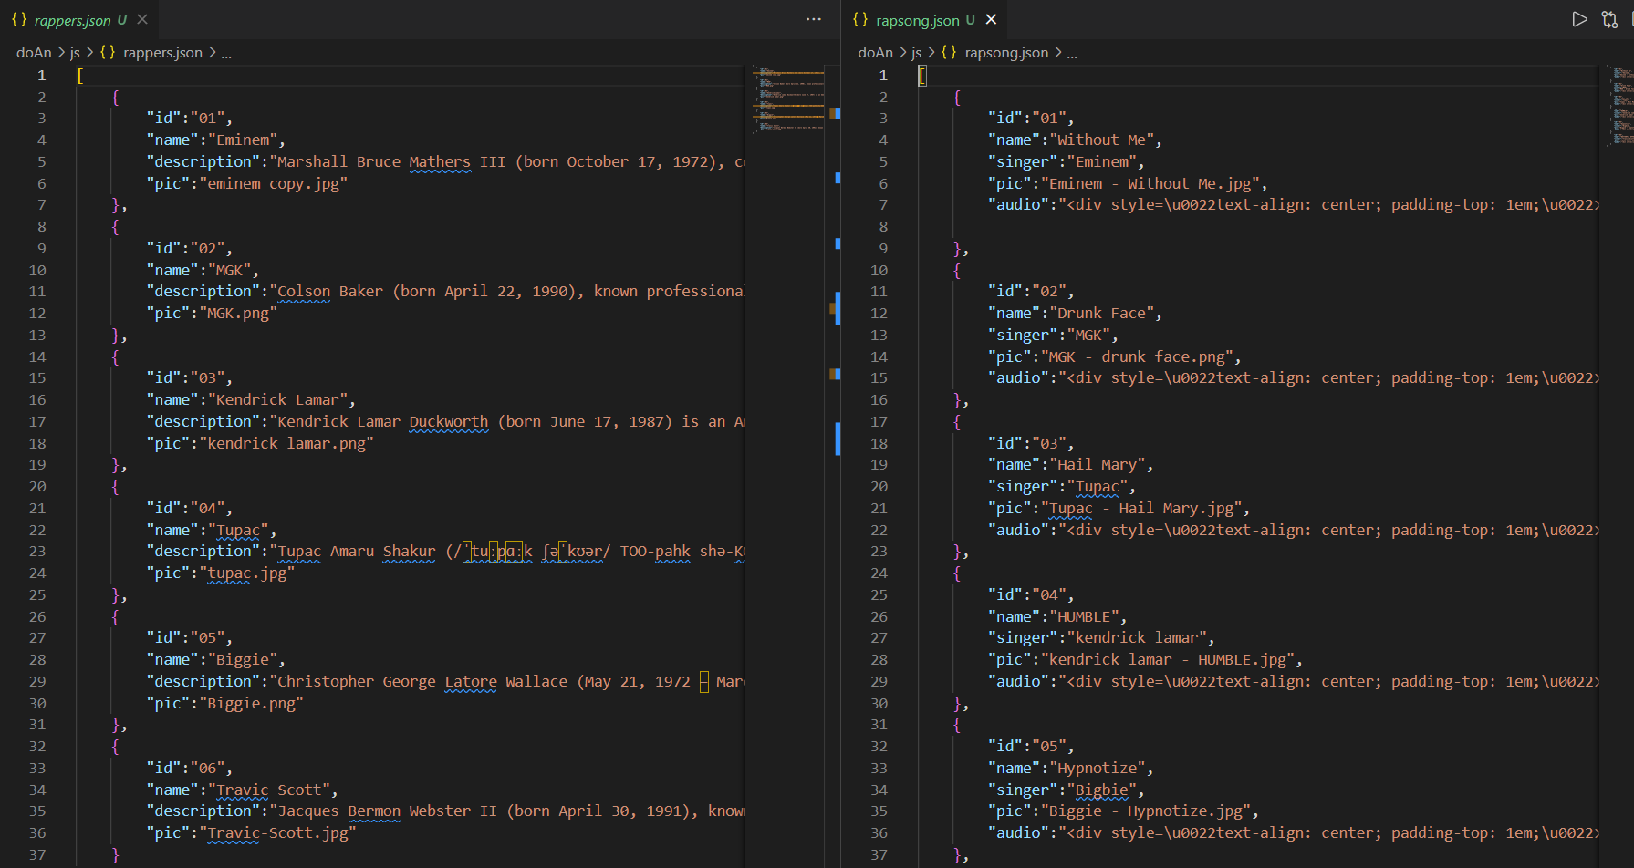

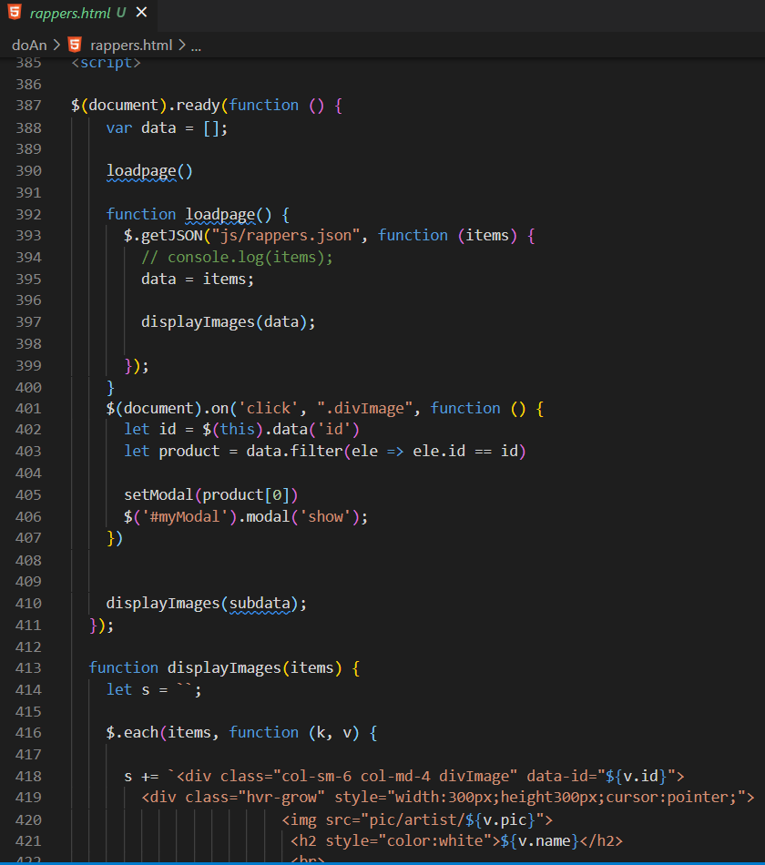

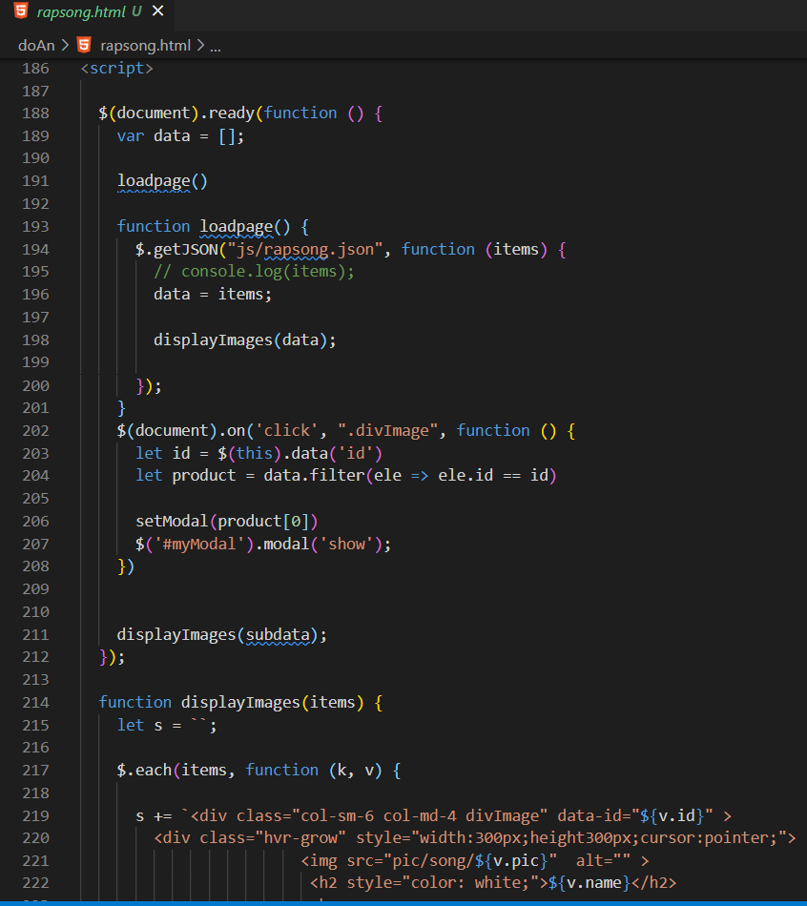

1. **JAZZ**

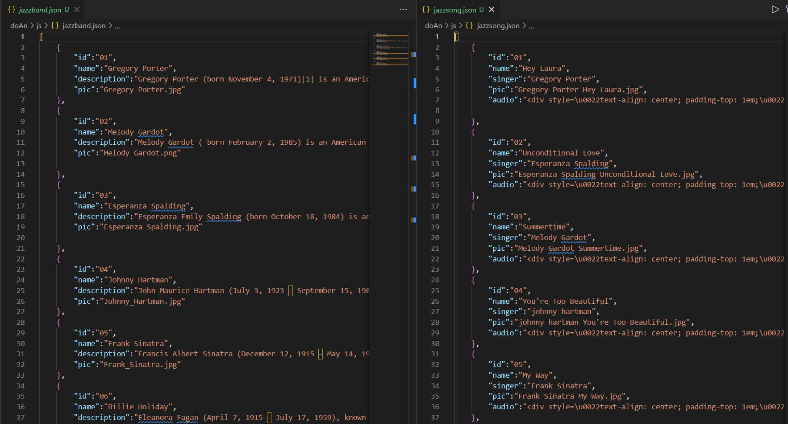

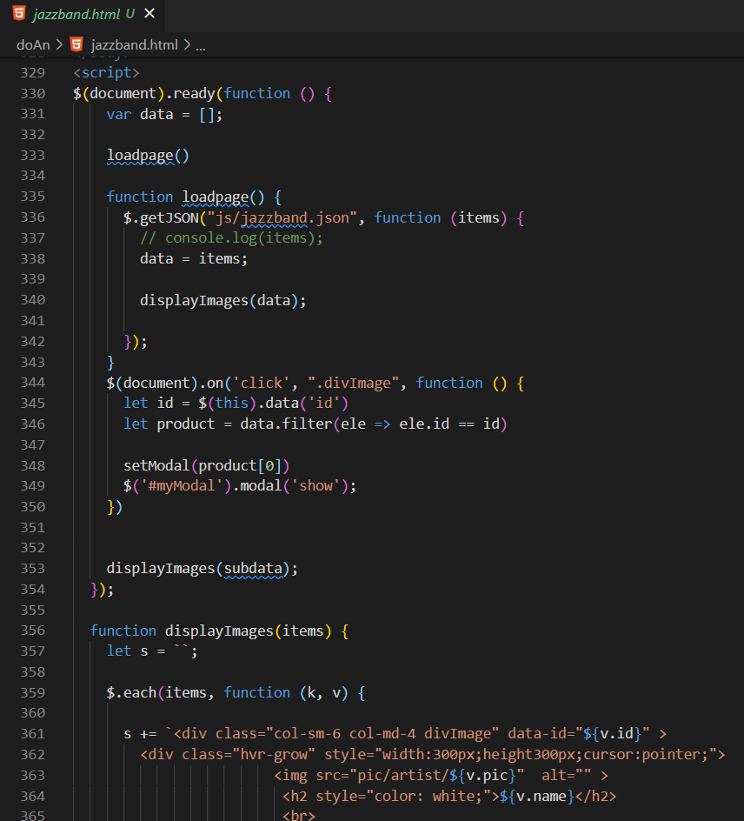

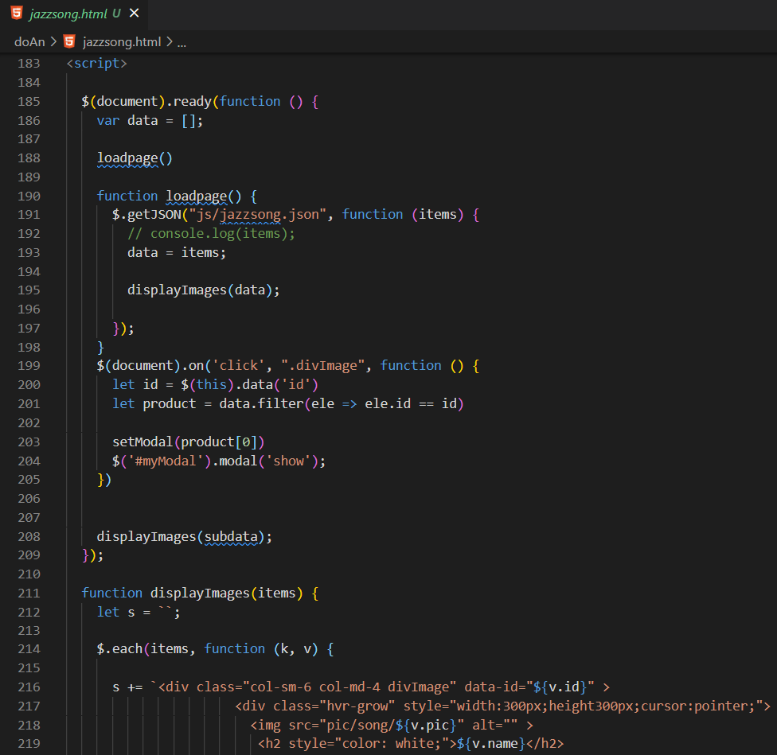

1. **CLASSICAL**

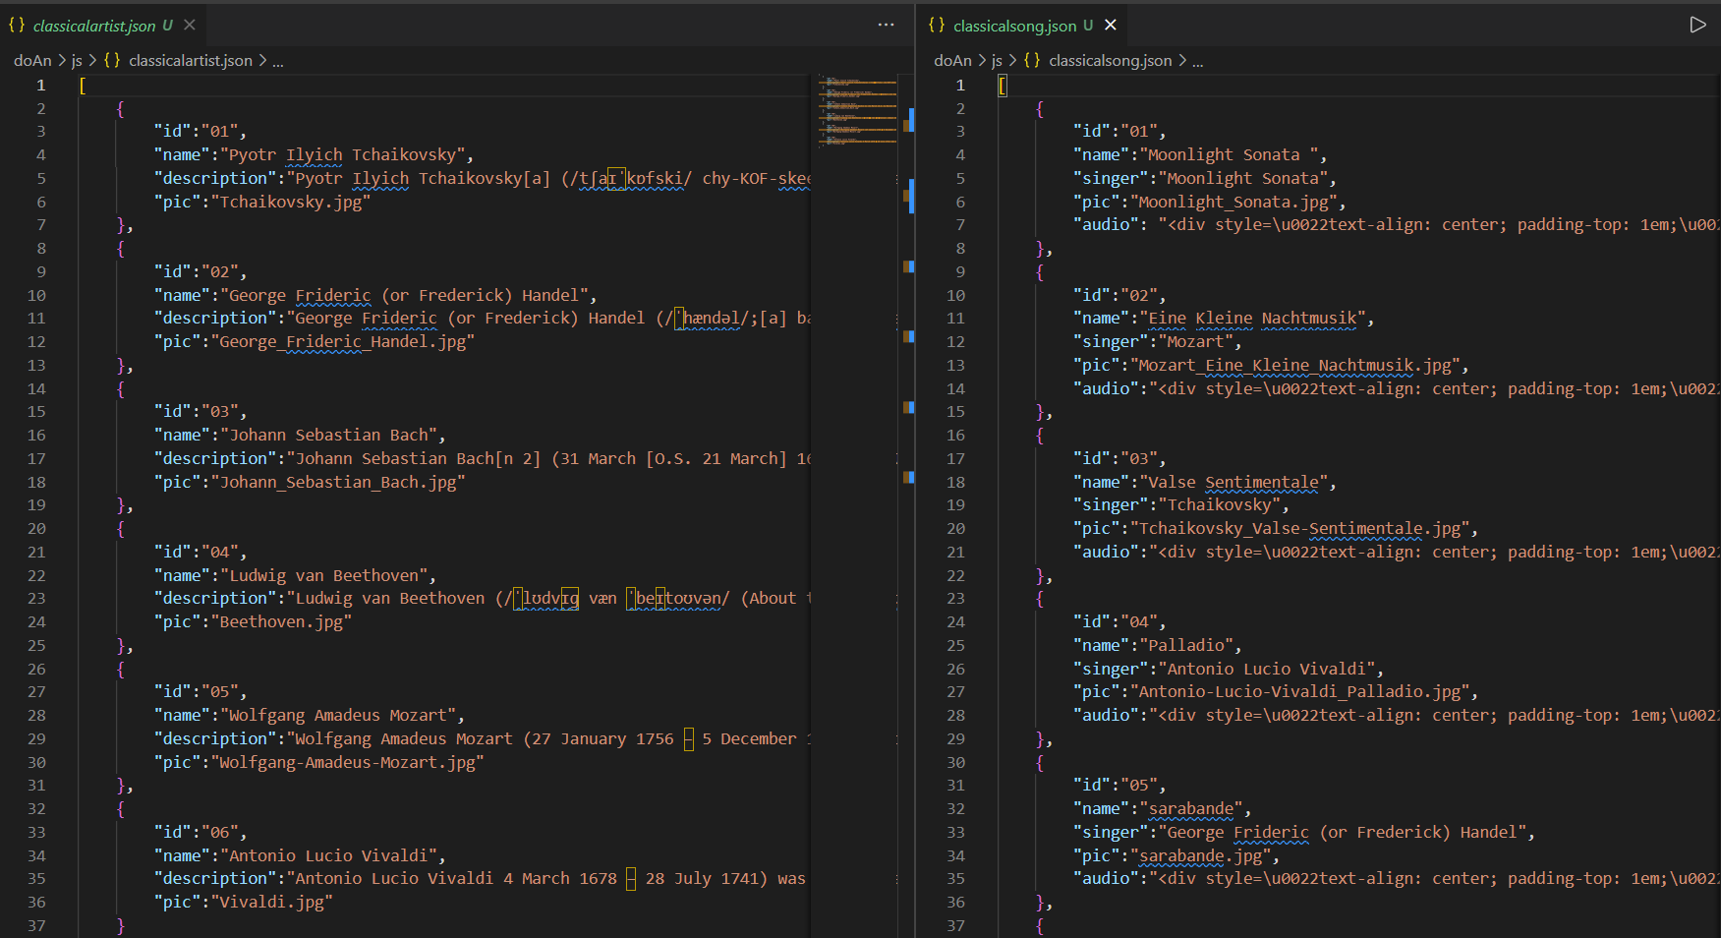

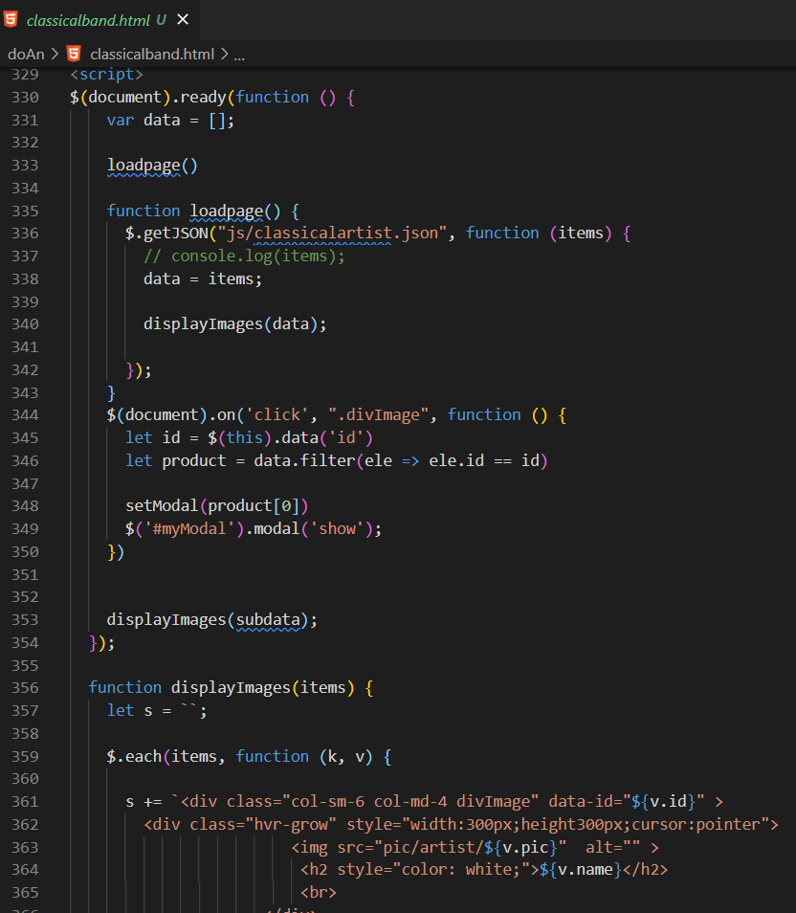

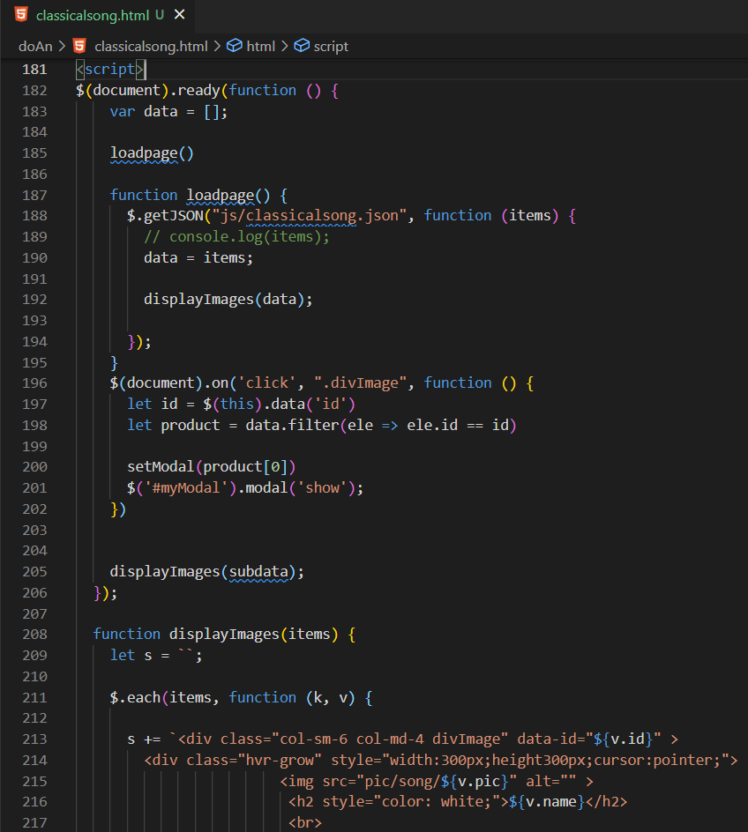

# TASK SHEET REVIEW 3

|  |  |  |  |  |  |  |  |
| --- | --- | --- | --- | --- | --- | --- | --- |
|  | | Project Title: | Activity Plan Prepared By: | Date of Preparation of Activity Plan: | | | |
| Sr. No. | Task | Music World | Minh | Actual  Start Date | Actual Days | Team  Mate Names | Status |
| 1 | Home page | 22-Nov-2021 | 1 | Long | Completed |
| 2 | Rock page | 10-Dec-2021 | 1 | Long | Completed |
| 3 | Jazz page | 13-Dec-2021 | 1 | Duy | Completed |
| 4 | Pop page | 20-Dec-2021 | 2 | Long | Completed |
| 5 | Rap page | 21-Dec-2021 | 1 | Long | Completed |
| 6 | Classical page | 21-Dec-2021 | 2 | Long | Completed |
| 7 | About | 15-Dec-2021 | 1 | Long | Completed |
| 8 | Log in | 14-Dec-2021 | 1 | Minh | Completed |

|  |  |
| --- | --- |
| Date: | |
| **Signature of Instructor:**  **Ms. Le Mong Thuy** | **Signature of Team Leader:**  **La Bao Minh** |